Index of Facebook Recipe Collection # 5 by Page Number

- Pepperoni Stromboli
- Minestrone Soup
- Easy Christmas Divinity
- Rosarita® 7 Layer Dip
- Cheesy Baked Dip
- Hot Apple Dumplings
- Pizza Casserole
- Peanut Butter “Cheese Ball”
- Picadilly's Carrot Souffle
- Olive Garden Zuppa Toscana Soup
- Grand Slam Stuffed Burger
- Softest Sugar Cookie Recipe
- White Chocolate Peanut Butter Fudge Bites
- Layered Pudding Delight
- Perfect Pasta Salad
- Amish Sausage Balls
- Loaded Jalapeno Poppers
- Confetti Bites
- King Ranch Casserole
- Chicken-Fried Steak Casserole
- Loaded Barbecue Baked Potato Casserole
- Apple Pie Bites
- Enchilada Meat Loaf
- Quick Dinner
- Chicken -N- Dressin' Casserole
- Pumpkin Dessert Bars
- Baked Chicken Enchiladas
- Oven-Roasted Sausages, Potatoes, And Peppers
- Parmesan Garlic Roasted Potatoes
- Butterfinger Ice Cream Cake
- Bacon Cheeseburger Rolls
- Chocolate Chip Cookie Dough Bites ~ No Egg ~
- Baked Cheese & Broccoli Patties
- Old Fashioned Custard Pie
- Cherry Blossom Snowballs
- Runza Casserole
- One Hour Yeast Rolls
- Biscuit Cinnamon Roll
- Fettuccine Alfredo With Jumbo Lump Crab
- Crock Pot Corned Beef And Cabbage
- Cajun Crab Balls
- Apple Pie Moonshine
- Earthquake Cake
- Crispy Cheddar Chicken
- Chocolate Eclair Cake
- Lemon Sugar Cookies
- Homemade Ranch Dressing – The Best
- Homemade Hershey’s Chocolate Syrup
- Almond Joy Cookies
- Homemade Somoa Cookies
- Bacon Wrapped Asparagus
- Roasted Strawberry Banana Bread
- Cinnamon-Sugar Pizza
- One Hour Cinnamon Rolls
- Pull-Apart Cinnamon Sugar Pumpkin Bread
- Caramel Crispix
- Baked Croissant French Toast
- The Best Potato Soup Recipe Ever
- No Bake Pumpkin Oatmeal Cookies
- Baked Margarita Spaghetti Squash
- Pumpkin Bread With Pumpkin Butter
- Gooey Butter Cookies
- Fried Green Tomatoes
- Turtle Cookie Bars
- Cabbage & Noodles With Bacon
- Chocolate Brownie Cookies
- Crock Pot Chicago Italian Beef Sandwiches
- Fudge Brownie Pie
- Bacon Bombs
- Biscuits & Gravy Casserole
- Easy Taco Melts
- Snickerdoodle Pumpkin Walnut Bread
- Almond Joy Cookies
- Easy Serve Breakfast

PEPPERONI STROMBOLI
Ingredients:
1 Pillsbury Classic Pizza Crust (they come in the cans)
2 eggs
1 tablespoon parmesan cheese
1 teaspoon oregano
1 teaspoon parsley
1/2 teaspoon garlic powder
1/4 teaspoon pepper
2 tablespoons vegetable oil
1/2 pound pepperoni
1/2 pound (2 cups) mozzarella cheese
Directions:
Preheat oven to 350°.
Open up your crust and roll out flat. It will be a rectangle shape.
Separate your egg yolks from the egg whites.
Place the egg yolks in a bowl and mix your parmesan cheese, oregano, parsley, garlic powder, pepper and vegetable oil.
Spread your mixture evenly onto your crust. (I used a spatula to spread)
Layer on all of your pepperoni.
Top with all of the cheese.
Starting on one end, roll up like a jelly roll.
Pinch the ends of your dough together to seal it all together.
Brush the outside of the dough with your egg whites (I used a pastry brush to do this)
Spray some non-stick cooking spray onto a baking sheet and place your stromboli on top.
Bake in 350° oven for about 20-25 minutes.
Remove and enjoy!!

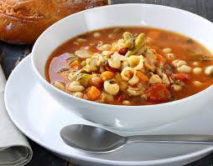
Minestrone Soup
Newfoundland Recipe
1 large can diced tomatoes
1 can tomato soup
1 can kidney beans
1 cup sliced carrots, cooked (or 1 can sliced carrots)
2 cubes or envelopes beef bouillon, dissolved in 2 cups water
1/2 cup macaroni
1 lb ground beef, cooked
1 onion, chopped and cooked with the ground beef
salt, pepper, garlic powder, oregano, basil and other spices to taste
Combine all ingredients in large pot. Simmer until macaroni is cooked. Serve with garlic bread.

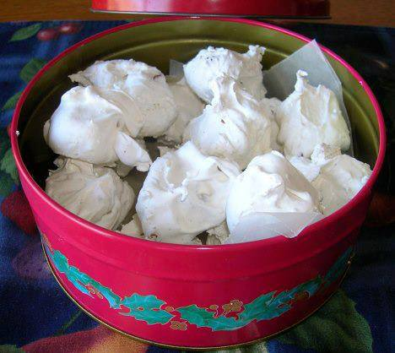
Easy Christmas Divinity
2 cups white sugar
1/3 cup water
1/3 cup light corn syrup
1/4 teaspoon salt
2 egg whites
1 teaspoon vanilla extract
1/2 cup pecans or nuts of your choice, chopped
Combine sugar, water, corn syrup and salt in a glass casserole dish. Cover with saran wrap and microwave on high for 5 minutes. Remove from microwave and take off saran wrap. Stir well and return to microwave uncovered. Cook on high for another 4 to 5 minutes until reaches hard ball stage when a little is dropped in cold water. Remove and cool about 4 minutes. Beat egg whites until stiff with mixer. Pour sugar mixture over egg whites beating constantly with mixer until mixture starts to lose its gloss and holds together. About 4 or 5 minutes. Stir in vanilla and nuts. Drop by teaspoonful onto wax paper. Makes about 25 pieces depending on size you make them. Enjoy!

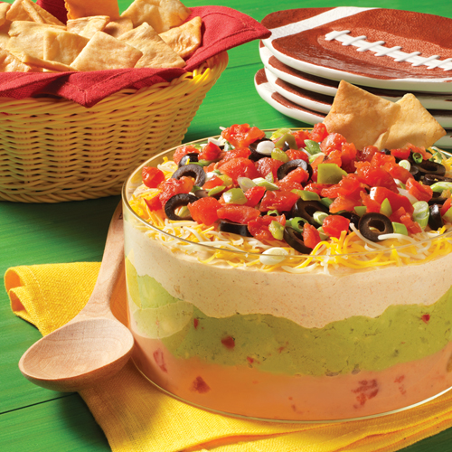
Rosarita® 7 Layer Dip

INGREDIENTS
1 can (10 oz each) Ro*Tel® Original Diced Tomatoes & Green Chilies, drained, liquid reserved
1 can (16 oz each) Rosarita® Traditional Refried Beans
1 container (12 oz each) refrigerated guacamole
1 container (16 oz each) sour cream
1 pkg (1.25 oz each) taco seasoning mix
1 cup shredded Cheddar and Monterey Jack cheese blend
1 can (2.25 oz each) sliced ripe olives, drained
1/4 cup sliced green onions
Pita chips, optional

DIRECTIONS
Reserve 1/2 cup drained tomatoes; set aside. Blend remaining tomatoes and reserved liquid with beans in medium bowl.
Spread bean mixture in 8x8-inch glass baking dish or round casserole dish. Top with guacamole.
Blend together sour cream and seasoning mix in small bowl. Spread over guacamole. Top evenly with layers of cheese, olives, green onions and reserved tomatoes. Chill 2 hours prior to serving. Serve with pita chips, if desired.

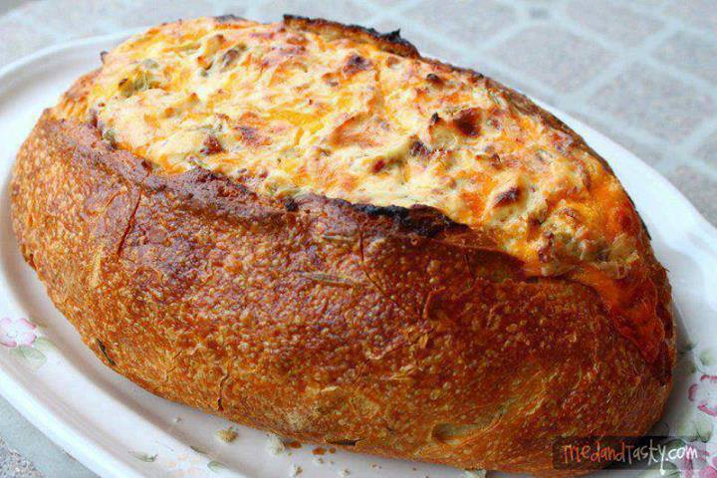
Cheesy Baked Dip
8 oz. sour cream
8 oz. cream cheese
16 oz. cheddar cheese, grated (sharp or mild)
4 oz. chopped green chilies
Green onion (suit your own taste)
1 c. chopped ham
1/2 pound chopped bacon
1 round bread loaf, hollowed out
Mix first seven ingredients together and put into the hollowed out bread loaf. Bake at 350 degrees uncovered for one hour. Serve with leftover bread or chips...

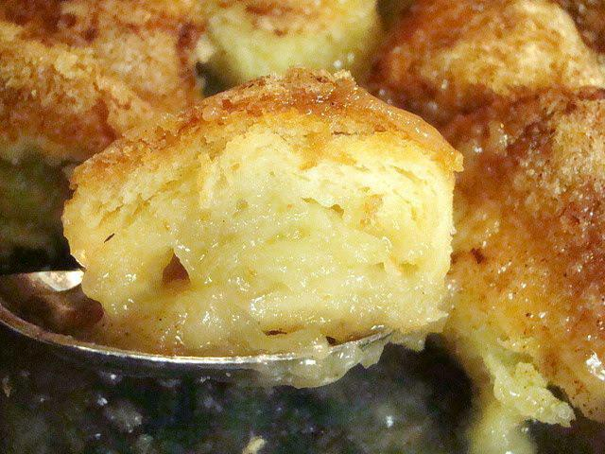
Hot Apple Dumplings
2 Granny Smith apples
1 cup water
1 cup sugar divided
1 stick butter
1/4 tsp. vanilla extract
8 canned biscuits (I use Pillsbury buttermilk)
4 teaspoons ground cinnamon
Preheat oven to 375 degrees. Peel, core and slice apples vertically into 8 slices each. Cover with cold water to keep them from getting brown while you prepare the rest of the recipe.
In a medium saucepan, mix the water, 3/4 cup of the sugar, butter and vanilla over heat and bring mixture to a boil.
Separate each biscuit in half. Wrap biscuit dough layer around a slice of apple, stretching it to slightly overlap and seal the bottom.
Place the wrapped slices sealed side down in a 9 X 13 baking pan. Pour the hot sugar mixture over the apple slices.
Mix the remaining 1/4 cup sugar with cinnamon and sprinkle over the tops of the wrapped apples. Bake for 35 minutes or until golden brown. Serve warm with vanilla ice cream! YUM!

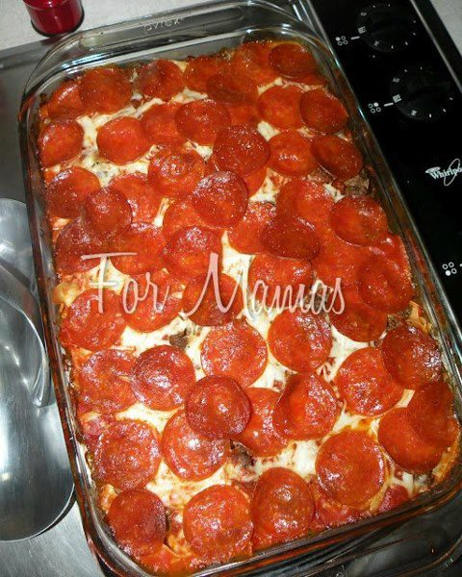
Pizza Casserole

Ingredients:
1 bag of Egg Noodles
1 extra large can of Ragu sauce {or any tomato sauce you prefer}
3 cups shredded mozzarella cheese {or more depending on how much you
cheese!}
1 1/2 lbs. hamburger meat
1package pepperonis
preheat the oven @ 350
Now the layering starts!
Start with a thin layer of tomato sauce on the bottom.
Layer~
half of the noodles
half of the meat
half of the sauce
rest of the noodles
half the cheese
rest of the meat
rest of the sauce
rest of the cheese
Finally ~pepperonis
Now cover with foil, and bake for 30 minutes
After 30 minutes, remove the foil & bake for another 15 minutes

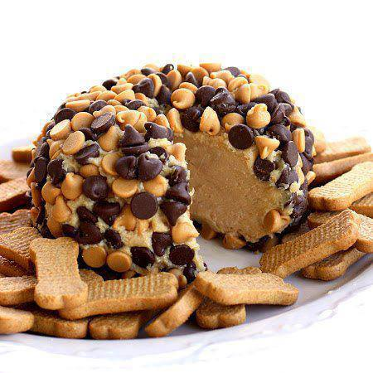
Peanut Butter “Cheese Ball”
Ingredients:
1 package (8 ounces) cream cheese, at room temperature
1 cup powdered sugar
3/4 cup creamy peanut butter (not all-natural)
3 tablespoons packed brown sugar
3/4 cup milk chocolate chips
3/4 cup peanut butter chips
Graham cracker sticks, teddy grahams, and/or apple slices for dipping
Instructions:
Beat cream cheese, powdered sugar, peanut butter and brown sugar in large mixer bowl until blended.
Spoon onto a large piece of plastic wrap; bring up all four corners and twist tightly forming into a ball shape.
Freeze for 1 hour 30 minutes or until firm enough to keep its shape. Place peanut butter and chocolate chips in flat dish. Remove plastic wrap from ball and roll ball
into morsels to completely cover, pressing morsels into the ball if necessary.
Place ball on serving dish; cover and freeze for 2 hours or until almost firm. (Can be made ahead. If frozen overnight, thaw at room temperature for 20 to 30 minutes before serving.) Serve with graham cracker sticks, teddy grahams, or apple slices for dipping or spreading.

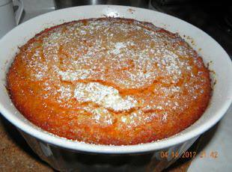
Picadilly's Carrot Souffle
Ingredients:
1 3/4 lbs peeled carrots
3/4 cup sugar
1 1/2 teaspoons baking powder
1 1/2 teaspoons vanilla
2 tablespoons flour
3 eggs
1/4 lb margarine, softened
Powdered sugar
1 Steam or boil carrots til extra soft& drain well.
2 While carrots are warm, add sugar, baking powder and vanilla.
3 Whip with mixer til smooth.
4 Add flour and mix well.
5 Whip eggs separately and add to mixture, blending well.
6 Add margarine and blend well.
7 Pour mixture into baking dish-ABOUT HALF FULL--as the souffle will rise.
8 Bake@ 350 about 1 hour or until top is light brown.
9 Sprinkle lightly with powdered sugar before serving.

Olive Garden Zuppa Toscana Soup
1 pound spicy Italian sausage
1/2 pound bacon, chopped
7 cups water
3 chicken flavored bouillon cubes
2 large russet potatoes, scrubbed clean and cubed
2 cloves garlic, chopped
1 medium onion, chopped
2 cups chopped kale
1 cup heavy whipping cream
salt and pepper, to taste
Directions
In a dutch oven or large soup pot over medium-high heat, brown sausage, breaking into small pieces as you fry it; drain, set aside.
In the same dutch oven or large soup pot over medium-high heat, brown bacon; remove and set aside. Leave two tablespoons of rendered bacon fat in the skillet.
Saute the potatoes, onion, and garlic in the rendered bacon fat over medium or low-medium heat. Saute until the onion begins to be translucent and the potatoes have are still a little firm, but are beginning to soften.
Add the sausage, bacon, 7 cups water, and 3 chicken bouillon cubes to the pot. Simmer until the potatoes are tender.

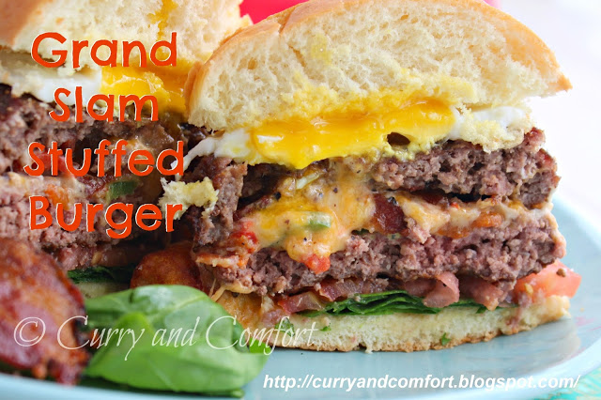
Grand Slam Stuffed Burger

Ingredients: (Makes 4 Stuffed burgers)

1.5 lbs of ground beef
6-8 slices of bacon cut in half and fried until crispy
Salt and black pepper to taste
4 fried eggs
Jalapeno Pimento Cheese (recipe below)
Baby spinach or lettuce
sliced red tomato
Mayonnaise

Jalapeno Pimento Cheese:
1 cup sharp cheddar cheese
1/2 cup mozzarella cheese
1/3 cup cream cheese
1/2 tsp garlic powder
1/2 tsp black pepper
red chili flakes to taste
2-3 Tbs chopped jalapeno
2-3 Tbs jarred pimento peppers

Directions:

Divide beef into four equal portions. Divide each portion into two halves (making the top and bottom of the stuffed burger) and season both sides well with salt and black pepper. Place one patty half into the Burger Press and press down so a well is made into the beef. Fill well with 2-3 pieces of cooked bacon and 2-3 Tbs of Jalapeno Pimento cheese mixture. Place 2nd half of beef patty (seasoned with salt and black pepper) and press with burger press to make stuffed burger.

Heat Cast Iron Griddle with some canola oil on medium-high heat and place stuffed burger. Cook on both sides until beef is cooked through (about 5-6 minutes on each side) so the cheese melts inside the burger. Place on a toasted burger bun slathered with some mayo and garnish with fried egg, tomato and spinach leaves or lettuce. Enjoy.

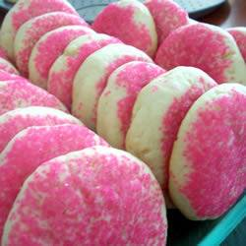
SOFTEST SUGAR COOKIE RECIPE
This Recipe is a State Fair Blue Ribbon winner. This is an easy sugar cookie recipe, you don't have to roll it out, and the cookies are soft and chewy, unlike other sugar cookies. Anybody can make these
Ingredients
Original recipe makes 4 1/2 dozen
2/3 cup shortening
2/3 cup butter
1 1/2 cups white sugar
2 eggs
2 teaspoons vanilla extract
3 1/2 cups all-purpose flour
2 teaspoons baking powder
1 teaspoon salt
1/3 cup granulated sugar for decoration
Directions
Preheat oven to 350 degrees F (175 degrees C).
In a medium bowl, cream together the butter, shortening and sugar. Stir in the eggs and vanilla. Combine the flour, baking powder and salt, stir into the creamed mixture until dough comes together. Roll dough into walnut sized balls and roll the balls in sugar. Place them on an unprepared cookie sheet about 2 inches apart.
Bake cookies 10 to 12 minutes in the preheated oven, until bottom is light brown. Remove from baking sheets to cool on wire racks.

Variations: Add a touch of Almond or Orange Extract, to give your cookies a little different flavor.

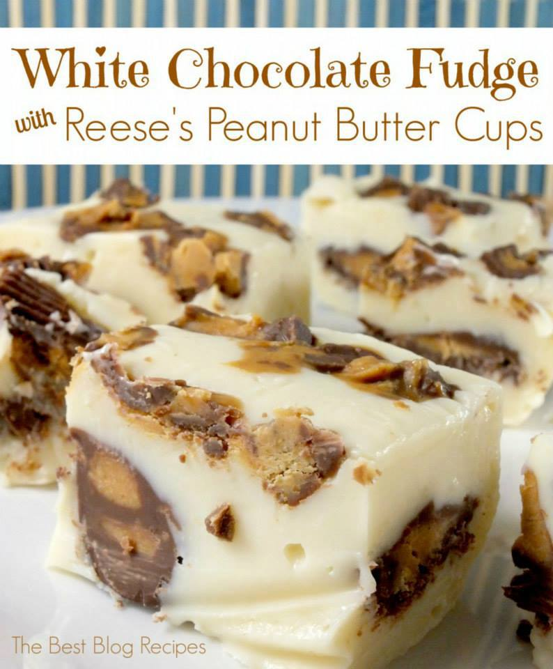
WHITE CHOCOLATE REESES PEANUT BUTTER CUP FUDGE BITES
INGREDIENTS:
22 REESE'S Peanut Butter Cups
3 cups of white chocolate chips
1-14 oz can of sweetened condensed milk
Directions:
Line a 9x9 casserole dish with foil. Lightly spray it with cooking spray.
Arrange your Peanut Butter Cups on the bottom (16 total)
In a large sauce pan add your white chocolate chips & sweetened condensed milk and heat over medium low heat until all of the chocolate has melted.
Once everything is well combined immediately pour the chocolate/milk mixture over your peanut butter cups.
Chop the remaining 6 peanut butter cups into smaller pieces and spread evenly over the top of the mixture and press down slightly.
Let cool on the counter for a while and then cover with plastic and put in the fridge to cool completely. We've actually just stored our fudge in the fridge to keep it longer since it made so much!
Once it's cooled in the fridge for a couple of hours you can cut into bite sized pieces, or huge chunks... it's up to you.

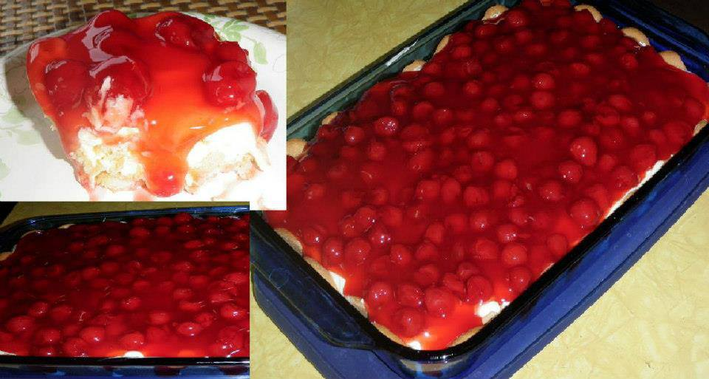
Layered Pudding Delight
14 graham crackers
1 pkg. Instant Vanilla pudding
2 cups cold milk
1 cup cool whip
1 can cherry pie filling
Mix pudding with milk and cool whip.
In 9x9 pan layer bottom with crackers, next ½ of
the vanilla pudding mixture, next crackers,
next last ½ of pudding mixture and top with cherry pie filling.
Chill over night….serve.
Double recipe for 9x13 pan.
Variations:
use vanilla wafers in place of graham crackers
use chocolate pudding in place of vanilla pudding
use blueberry pie filling in place of cherry

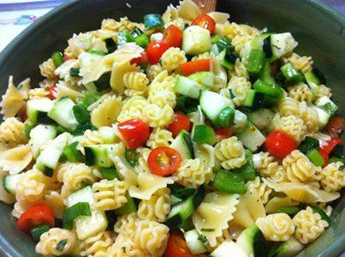
Perfect Pasta Salad
1 green pepper chopped
1 package green onions chopped
1 box cherry tomatoes
2 cucumbers chopped
16 oz pasta
1 tsp prepared mustard
1 tsp garlic powder
1 tsp salt
1 tsp pepper
1 tsp parsley flakes
1 1/4 cup sugar
1 1/4 cup cider vinegar
2/3 cup vegetable oil
Chop all vegetables and place in a bowl. Cook pasta then drain and cool. Mix all other ingredients together in a separate bowl. After dressing is mixed combine all ingredients, chill, and serve.

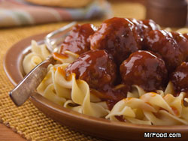
Amish Sausage Balls
This Pennsylvania Dutch recipe for Amish Sausage Balls is so versatile! Whether as a crowd-pleasing appetizer or as a robust main dish, the Amish country flavors come through as loud and clear as the sound of a horse and buggy coming down a country road.
Yields: 26 to 28 balls - Cooking Time: 30 min
INGREDIENTS:

1 pound Italian sausage, casing removed
1/2 cup plain bread crumbs
1/4 cup finely chopped onion
1 egg, beaten
2 teaspoons vegetable oil
1 1/2 cups ketchup
1/4 cup white vinegar
2 tablespoons soy sauce
1/2 cup light brown sugar

What To Do:
In a large bowl, combine sausage, bread crumbs, onion, and egg; mix well then form into 1/2-inch balls.
In a large skillet over medium-high heat, heat oil; brown sausage balls 5 minutes, stirring occasionally.
Meanwhile, in a medium bowl, combine remaining ingredients; mix well.
Pour over sausage balls, cover, reduce heat to low, and simmer 20 to 25 minutes, or until no longer pink in center. Serve immediately.
Note These are traditionally served over rice or curly noodles. However, we also found these perfect as an appetizer served on toothpicks. If you want to make these ahead of time, that's fine. Just reheat on a baking sheet in a 250 degree oven.

Loaded Jalapeno Poppers
Need something tasty to tide your hungry gang over before dinner's served? Well, who could resist popping our Loaded Jalapeno Poppers in their mouth! They're a little bit hot, a little bit smoky, a little bit creamy, and a whole lot of tasty!
Makes: 2 dozen Cooking Time: 20 min
Ingredients:
1 (8-ounce) package cream cheese, softened
1 cup shredded sharp Cheddar cheese
3 tablespoons bacon bits
12 fresh jalapeno peppers, split in half lengthwise, cutting through stems, seeds removed
1/3 cup all-purpose flour
2 eggs, lightly beaten
1/2 cup bread crumbs
Vegetable oil for frying

Instructions:
In a medium bowl, combine cream cheese, Cheddar cheese, and bacon bits. Firmly press a heaping teaspoonful of cheese mixture into each pepper half. Cover and chill 1 hour.
Place flour, eggs, and bread crumbs in 3 separate shallow dishes. Dip stuffed pepper halves into flour, then eggs, then bread crumbs, coating thoroughly with each.
Fill a large saucepan or soup pot with 2 inches of oil and heat over medium-high heat until hot but not smoking. Carefully fry a few peppers at a time, 1 to 3 minutes, or until golden. Drain on paper towels and serve immediately.
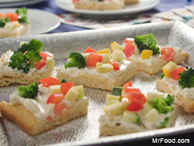
Confetti Bites
Chopped fresh veggies resemble a sprinkling of confetti on this quick cream-cheesy appetizer. Pre-packaged crescent rolls do the work for us!
Cooking Time: 20 min
Ingredients:
2 packages (8 ounces each) refrigerator crescent rolls
2 packages (8 ounces each) cream cheese, softened
3 tablespoons mayonnaise
1/2 teaspoon dried basil
1/4 teaspoon garlic powder
3 cups finely chopped fresh vegetables (cucumbers, tomatoes, broccoli, bell peppers, or any colorful combination of your favorites)

Instructions:
Preheat the oven to 350 degrees F.
Press the crescent roll dough onto a 10" x 15" cookie sheet to form a crust. Bake for 10 to 15 minutes or until light golden, then allow to cool. Meanwhile, in a medium-sized bowl, combine the cream cheese, mayonnaise, basil, and garlic powder.
Spread the mixture thinly over the cooled crust. Top with the chopped vegetables. Cut and serve. Makes 20 squares.

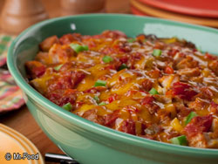
King Ranch Casserole
This stick-to-your-ribs Tex-Mex casserole gets its name from the biggest ranch in Texas (and the world!): King Ranch! So of course, it's big on taste and sure to satisfy your gang's big appetites.
Serves: 6 Cooking Time: 45 min

Ingredients:

1 tablespoon vegetable oil
1 large green bell pepper, diced
1 cup chopped onion
2 garlic cloves, minced
1 (10-3/4-ounce) can cream of chicken soup
1 (14.5-ounce) can diced tomatoes with green chilies
1 to 2 tablespoons chili powder
12 corn tortillas, cut into 1/2-inch strips
4 cups diced cooked chicken
2 cups shredded sharp Cheddar cheese

Instructions:
1. Preheat oven to 350 degrees F. Coat a 9- x 13-inch baking dish with cooking spray.
2. In a large skillet, heat oil over medium heat. Saute bell pepper, onion, and garlic 4 to 5 minutes, or until
tender. Stir in soup, diced tomatoes, and chili powder. Cook just until warmed.
3. Line bottom of prepared baking dish with half the tortilla strips. Sprinkle half the chicken over tortilla
strips, top with half the vegetables , and half the cheese. Repeat layers.
4. Bake 30 to 35 minutes, or until bubbly and hot.

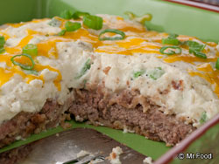
Chicken-Fried Steak Casserole
You don't have to be a southerner to enjoy this down-home favorite.
Serves: 4 Cooking Time: 30 min

Ingredients:

1/4 cup all-purpose flour
1/2 teaspoon salt
1/4 teaspoon black pepper
1 1/4 pounds beef cubed steak
1 egg
1/4 cup milk
3/4 cup dry bread crumbs
1/4 cup vegetable oil
1 (24-ounce) package refrigerated mashed potatoes
3 scallions, thinly sliced
1/2 cup shredded Cheddar cheese

What To Do:
1. Preheat oven to 375 degrees F. Coat an 8-inch square baking dish with cooking spray.
2. In a shallow dish, combine flour, salt, and pepper. Coat steak in mixture and set aside.
3. In a medium bowl, combine egg and milk; mix well. Place bread crumbs in a shallow dish.
4. Dip coated steak into egg mixture, coating completely, then into bread crumbs; set aside. Discard any
remaining coating mixture.
5. In a large deep skillet, heat oil over medium-high heat until hot, but not smoking. Add steak and cook 6
to 8 minutes, or until juices run clear and coating is golden brown, turning occasionally.
6. Place steak in single layer in prepared baking dish. Combine potatoes and scallions and spread over
steak. Sprinkle cheese over top.
7. Bake 20 to 25 minutes, or until potatoes are warmed through and cheese is melted.

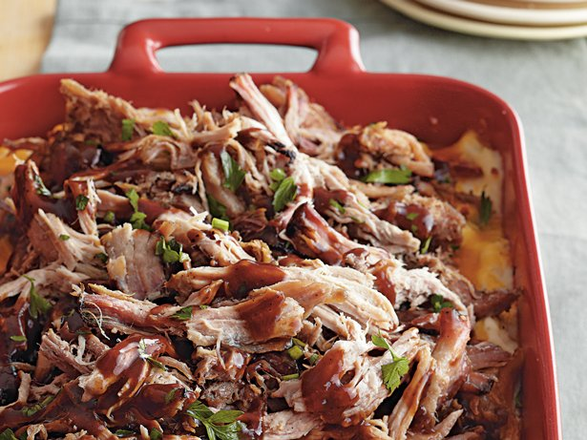
Loaded Barbecue Baked Potato Casserole

Ingredients:
6 slices bacon
1 bag (24 oz) frozen mashed potatoes
2/3 cup milk
1 cup shredded pepper Jack cheese (4 oz)
4 oz (half of 8-oz package) 1/3-less-fat cream cheese (Neufchâtel), cut into cubes
1/2 teaspoon pepper
3 cups shredded Cheddar cheese (12 oz)
1 container (8 oz) reduced-fat sour cream
1 can (4.5 oz) Old El Paso® chopped green chiles, drained
3 cups shredded barbecue pork or beef
3/4 cup barbecue sauce
Chopped fresh parsley, if desired

Instructions:
Heat oven to 350°F. Spray 13x9-inch (3-quart) glass baking dish with cooking spray.
In 10-inch skillet, cook bacon over medium-high heat 8 to 10 minutes or until crisp; drain on paper towels, reserving 2 tablespoons drippings. Crumble bacon; set aside.
In large microwavable bowl, stir together mashed potatoes, reserved bacon drippings, the milk, pepper Jack cheese, cream cheese, pepper and 2 cups of the Cheddar cheese. Microwave uncovered on High 4 minutes. Stir in sour cream and chiles until well blended.
Spoon potato mixture into baking dish. Sprinkle with bacon and remaining 1 cup Cheddar cheese. Spoon pork evenly over cheese. Drizzle barbecue sauce over pork.
Bake uncovered 45 minutes or until bubbly. Let stand 10 minutes before serving. Garnish with parsley.
Makes 10 servings

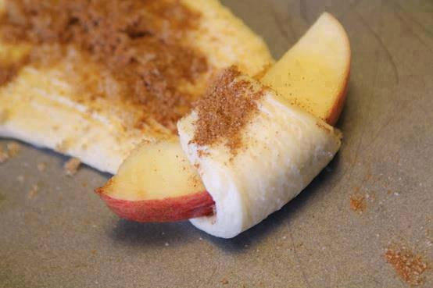
APPLE PIE BITES
1 tube Crescent rolls
1 Slice apple per triangle
Sprinkle with cinnamon & sugar
Roll up & Bake for 11-13 minutes at 350 degrees.

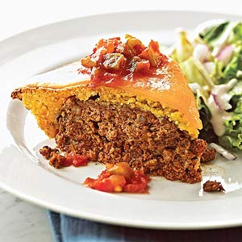
Enchilada Meat Loaf
Ingredients

1 egg, lightly beaten
1 medium onion, finely chopped
1/4 cup bottled salsa
2 tablespoons chili powder
3 cloves garlic, minced
1/2 teaspoon salt
1 pound ground beef
1 8 1/2 ounce package corn muffin mix
2 ounces sharp cheddar cheese, sliced
Bottled salsa (optional)

Directions
1. Preheat oven to 350 F. In a large mixing bowl combine egg, onion, 1/4 cup salsa, the chili powder, garlic, and salt; add ground beef and mix well. Shape into a ball and place in a 9-inch pie plate. Flatten meat mixture to a 6-inch circle; set aside.
2. Prepare corn muffin mix according to package directions. Spread corn muffin batter over meat mixture in pie plate. Bake about 50 minutes or until an instant-read thermometer inserted into the meat loaf registers 160F. Remove from oven. Halve cheese slices and arrange on top of the corn muffin mixture. Cover loosely and let stand 10 minutes before serving. If desired, serve with additional salsa. Makes 6 servings.

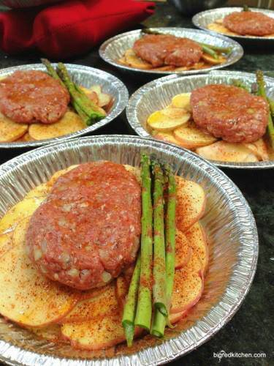
Quick Dinner

Here’s what I do: This will serve 6.
1. For each person thinly slice (about 1/8 inch) 2 red potatoes and place in pie pan or on a big piece of foil.
2. To make 6 Meat Patties- mix 1.5 pounds 85% lean ground beef, 2 eggs, 1 1/2 tsp. Dijon, 1 Tbsp. Worcestershire sauce, 1 tsp. salt and 1/2 tsp. pepper, and 1/2 cup finely chopped onions. Divide into 6 one inch thick patties.
3. Top each pan of potatoes with a meat patty and sprinkle the potatoes generously with seasoned salt or garlic salt and pepper, then drizzle with a olive oil, especially over the potatoes.
4. Cover with foil and bake at 400 degrees for 35-45 minutes or until potatoes are fork tender.
5. Serve with BBQ Sauce, Ketchup, or HP Sauce.

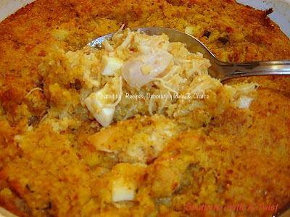
Chicken -n- Dressin' Casserole
Really easy and quick to make.
4 chicken breasts cooked and cubed
1 pan prepared cornbread, cooled and crumbled
4 eggs, boiled, chopped
1 small onion, chopped
1 teaspoon salt
1/2 teaspoon ground black pepper
1/4 teaspoon garlic powder
2 cups chicken broth
1 can condensed cream of mushroom soup
Combine all ingredients and place in a 13x9 baking dish. Bake at 350 for about 30-45 minutes or until set.

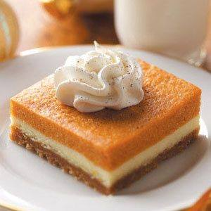
Pumpkin Dessert Bars
Ingredients:
- 1-3/4 cups graham cracker crumbs
- 1-1/3 cups Imperial Sugar® / Dixie Crystals® Granulated Sugar, divided
- 1/2 cup butter, melted
- 1 package (8 ounces) cream cheese, softened
- 5 eggs
- 1 can (15 ounces) solid-pack pumpkin
- 1/2 cup packed brown sugar
- 1/2 cup milk
- 1/2 teaspoon salt
- 1/2 teaspoon ground cinnamon
- 1 envelope unflavored gelatin
- 1/4 cup cold water
- Whipped topping and ground nutmeg, optional
Instructions:
- In a small bowl, combine graham cracker crumbs and 1/3 cup sugar; stir in butter. Press into a greased 13-in. x 9-in. baking dish.
- In a small bowl, beat cream cheese and 2/3 cup sugar until smooth. Beat in 2 eggs just until blended. Pour over crust. Bake at 350° for 20-25 minutes or until set. Cool on a wire rack.
- Meanwhile, separate remaining eggs and set whites aside. In a large saucepan, combine the yolks, pumpkin, brown sugar, milk, salt and cinnamon. Cook and stir over low heat for 10-12 minutes or until mixture is thickened and reaches 160°. Remove from the heat.
- In a small saucepan, sprinkle gelatin over cold water; let stand for 1 minute. Heat over low heat, stirring until gelatin is completely dissolved. Stir into pumpkin mixture; set aside.
- In a large heavy saucepan, combine reserved egg whites and remaining sugar. With a portable mixer, beat on low speed for 1 minute. Continue beating over low heat until mixture reaches 160°, about 12 minutes. Remove from the heat; beat until stiff glossy peaks form and sugar is dissolved.
- Fold into pumpkin mixture; spread evenly over cream cheese layer. Cover and refrigerate for 4 hours or until set. Garnish with whipped topping and nutmeg if desired. Yield: 15 servings.

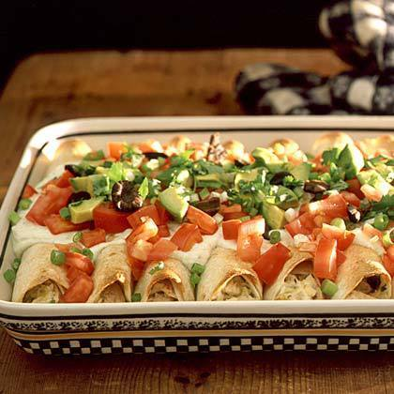
Baked Chicken Enchiladas
prep in advance & enjoy
Ingredients:
3 cups chopped cooked chicken(I use rotisserie)
2 cups shredded lite Mexican blend cheese
1/2 cup lite sour cream or plain non-fat yogurt
1 (4.5-ounce) can chopped green chiles, drained
1/3 cup chopped fresh cilantro
8 (8-inch) sprouted grain tortillas
Vegetable cooking spray
1 (8-ounce) container lite sour cream or plain non-fat yogurt
green taco sauce(I use bottled Trader Joe's)
Toppings: diced tomato, chopped avocado, chopped green onions, sliced ripe olives, chopped cilantro
Preparation:
Stir together first 5 ingredients. Spoon chicken mixture evenly over each tortilla, and roll up. Arrange in a lightly greased 13- x 9-inch baking dish. Coat tortillas with vegetable cooking spray.
Bake at 350° for 35 to 40 minutes or until golden brown.
Stir together sour cream and taco sauce. Spoon over hot enchiladas, and sprinkle with toppings. Serve & enjoy!

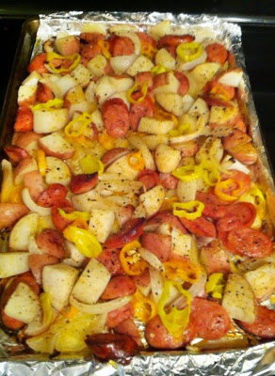
Oven-roasted Sausages, Potatoes, and Peppers

Ingredients:

1 package (at least 1 lb) of your favorite sausage links (johnsonvilles, evergood, generic smoked sausage, whatever you like. i used polish sausages, 4 to a pack)
4-5 decent-sized potatoes (i prefer yukon gold or red bliss)
1 small jar banana peppers
1-2 bell peppers, sliced
1 large onion, sliced
3 tbsp olive oil (yes, it has to be OLIVE oil)
salt & pepper
*optional — 2 tsp dried rosemary
*optional — 3 tbsp creole seasoning

Instructions:
Spray a large baking pan w/ nonstick spray (make sure there is at least a small “lip” that provides a “side” to the pan, don’t use a flat baking sheet.
Slice sausages into thin rounds, about 1/5″ thick. if you know how to slice using a “bias” cut, do that. if not, don’t worry about it.
Cut potatoes into 1/2″ chunks
Slice onion and pepper into strips
Place all ingredients on baking sheet and drizzle oil over. use your hands to toss everything together in the oil, making sure everything feels coated.
Add salt & pepper and spices (if using)
Top w/ sliced banana peppers
Bake at 400 for about 30-35 min, until potatoes are tender

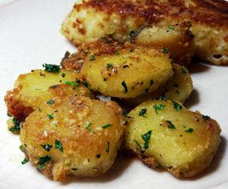
Parmesan Garlic Roasted Potatoes

Ingredients:

Potatoes Cut in to smaller size pieces (I use Russet Potatoes)
A few tablespoons of olive oil
2-3 cloves garlic, minced
1 to 2 Tablespoons fresh chopped parsley
Fresh grated Parmesan cheese
Salt and pepper, to taste

Instructions:
Preheat oven to 450 °F.
Cut potatoes into cubes or wedges. Bring a pot of water to a boil.
Add the potatoes and cook for 3 to 6 minutes depending on size.
While potatoes are cooking put oil in cast iron skillet or other heavy
pan and heat in oven.

Drain the potatoes and place them back in the pot. Put the pot back
on the burner and shake to dry the potatoes and to rough up their
surface. This is what gives roasted potatoes that perfect crust.

Add the potatoes to the hot oil , toss to coat and roast turning once or twice.
When potatoes are almost tender sprinkle with fresh
garlic and Parmesan, salt and pepper and continue roasting until
potatoes are tender. Turn at least one more time for even browning.

Just before serving, toss with fresh chopped parsley.

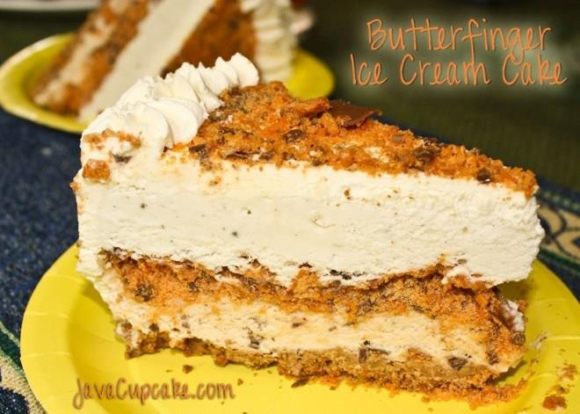
Butterfinger Ice Cream Cake

Prep time: 2-3 hours plus overnight, 1 more hour the next day

Ingredients:
Wilton 10″ Springform pan
Non stick spray
Large mixing bowl
2 half gallons of vanilla bean ice cream
8-10 Butterfinger King Size candy bars, crushed into very small pieces/crumbs
24 (full size) graham crackers, crushed into fine crumbs
8 tablespoons butter, melted
1/4 cup sugar
1 cup whipping cream
2 tablespoons sugar
1 tsp vanilla

Directions
At least 45 minutes before you begin, set out one half gallon of ice cream on the counter to soften. You want it partially melted, but not completely liquid.
Preheat your oven to 350 F degrees. Spray the bottom of the spring form pan with non-stick spray.
Combine crushed graham crackers with the sugar. Add the melted butter until all the graham crackers are moistened. Press graham crackers into the bottom of the spring form pan. You want to create about a 1/4 in crust. You may not need all the mixture. (Save the rest for another recipe!) Bake for 12-15 minutes or until golden brown. Cool on a wire rack completely.
After the crust has completely cooled, prepare your ice cream. In a large mixing bowl, mix one half gallon of softened ice cream with at least 1/2 cup of crushed Butterfingers.
Take out the 2nd half gallon of ice cream to soften.
Spread all of the Butterfinger ice cream on top of the graham cracker crust.
Reserve 1/4 cup of remaining Butterfinger for topping. Spread the rest evenly across the Butterfinger ice cream. Pat it down gently into the ice cream. Place springform pan in the freezer for 20-30 minutes or until the ice cream firms up. After it has firmed, spread the vanilla ice cream on top until it fills the pan. Cover with plastic wrap and freeze overnight.
Prepare the whipped cream frosting by beating the whipping cream with the whisk attachment on a stand mixer on high for several minutes. Add the vanilla and sugar gradually and slowly as it begins to whisk. You’ll know it’s done when its thick and fluffy in texture.
Apply a thin layer of whipped cream to the top and sides of your cake. I used a large star tip to create a decorative border around the top edge. Sprinkle the remaining crushed Butterfinger on the top.
Freeze for 1 hour or until ready to use. You’ll want the whipped cream to be solid.
Remove the cake from the 15 minutes before you want to serve.
Enjoy!
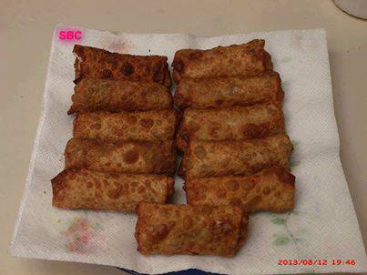
Bacon Cheeseburger Rolls
Ingredients:
ground beef
bacon
shredded cheese
eggroll wrappers
vegetable oil for frying (optional)
Condiments
Brown your ground beef and season it like you would do a hamburger. I seasoned mine with Creole seasoning, a few dashes of worcestershire sauce. After done, I drained the grease and then added in bacon that I had already prepared and chopped into pieces.
Wet your eggroll wrapper and place it in front of you so it looks like a diamond rather than a square
You want the filling to go straight from corner to corner.
Fill with ground beef and bacon mix and top with a nice heap of shredded cheese.
Roll by taking the bottom corner and tucking it under the filling. Then bring in both sides and continue to roll.
*Your wrapper needs to be wet so it will stick and not come apart when cooking.
I deep fried mine for added crispiness but you can place in the oven at 325 until brown.

Chocolate Chip Cookie Dough Bites ~ No Egg ~
1/2 cup butter
1/4 cup sugar
1/2 cup brown sugar
3 tablespoons of half and half
1 teaspoon vanilla
1 1/3 cup flour
2/3 cup mini chocolate chips
For the coating:
2 cups of chocolate chips (melted)
1 tablespoon shortening
Submitted By:" Kelli Jo Krominga Spray" Here's what I found online, as I was curious if they were baked as well...
Cream butter and sugar together.
Add remaining ingredients and mix well -- use your hands to get it together the best.
Roll into 1-inch balls.
Refrigerate until firm, about 30 minutes. Dip in chocolate, drizzle with chocolate or eat as is -- equally delicious no matter what!
Let stand at room temperature for about 10 minutes before serving.
Store in the refrigerator.

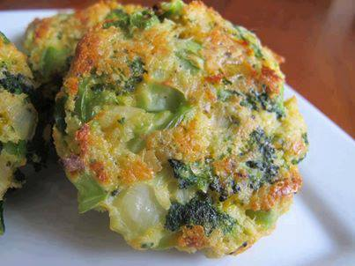
BAKED CHEESE & BROCCOLI PATTIES
- yield: 8 broccoli patties
INGREDIENTS
2 teaspoons vegetable oil
2 cloves garlic - minced
1/2 onion - chopped
1 (12 ounce) bag frozen broccoli - defrosted
3/4 cup panko breadcrumbs
1/2 cup sharp light cheddar cheese
1/3 cup parmesan cheese
2 eggs - beaten (can use whites for healthier version)
salt/pepper
INSTRUCTIONS
Preheat the oven to 400 degrees. Lightly grease a baking sheet lined with aluminum foil.
Heat the oil in a small pan over medium heat, add in the garlic and onions. Season with salt/pepper to taste. Sauté until onions are garlic are tender, set aside to cool.
Add the broccoli to a kitchen towel. Wrap the towel around the broccoli and squeeze out the extra moisture. Pour the drained broccoli into a large bowl, add the onion and garlic and mix gently.
To the same bowl, add the panko, the cheeses, eggs, and salt/pepper to taste.
Mix together and form into patties, place on the prepared baking sheet.
Bake in the preheated oven for 15 minutes. Flip and bake for another 15 minutes or until browned and crispy.

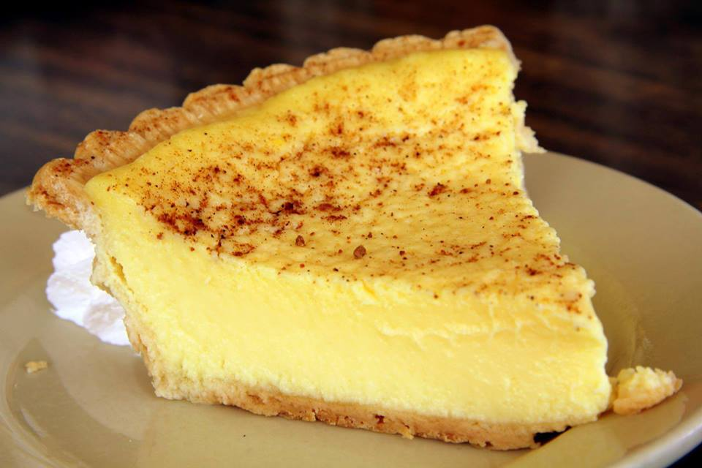
Old Fashioned Custard Pie
1 unbaked pie shell (I use Marie Callendar's deep dish)
3 large eggs
1/2 cup of sugar
1/2 teaspoon of salt
1/2 teaspoon of nutmeg
2-2/3 cups of milk
1 teaspoon pure vanilla extract
Pre-heat the oven to 350 degrees. Beat your eggs slightly, then add sugar, salt, nutmeg, and milk. Beat well and poor into the unbaked pie shell. Bake for 35 to 40 minutes. Remove from oven and cool. Sprinkle the top of pie with fresh ground nutmeg and serve.

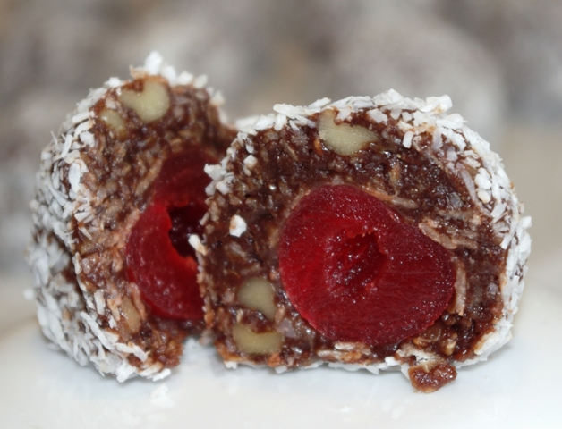
Cherry Blossom Snowballs

Makes 34 balls (1½“)

Ingredients:

3 cups rolled oats
2 cups unsweetened coconut (divided)
¾ cup cocoa (sifted)
1/2 cup walnuts (chopped)
Pinch of salt
1¼ cups evaporated milk
1 tsp vanilla
2 1/2 cups sugar
¾ cup butter (cut in sm cubes)
34 maraschino cherries
Method

In a large bowl, combine roll oats, 1 cup of coconut, cocoa, walnuts and salt – mix well and set aside.

In a large saucepan, med-low heat, combine milk, vanilla, sugar and butter. Stir until all ingredients are totally dissolved. Increase to med-high heat and bring to a gently boil (at this time do not stir mixture). Continue cooking for 10 minutes or until temperature reaches 230F on a candy thermometer or at the soft-ball stage.

Remove from heat and let mixture settle (approx 1 minute). Add mixture to dry ingredients and mix thoroughly. Place mixture in refrigerator until cool enough to handle or overnight. Shape into round balls insert a hole in center with finger, place a cherry in each and close. Coat by rolling in coconut.

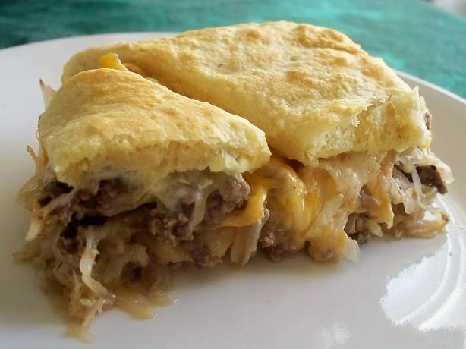
Runza Casserole:
2 Lbs. Ground Beef
1 Med. Onion, Chopped
1 Can Cream of Mushroom Soup
4 to 4 1/2 C. Finely Chopped Cabbage
2 Tubes Crescent Rolls
1 Can Cheddar Cheese Soup
Brown ground beef; drain well. Add onion, mushroom soup and cabbage. Stir together and cover. Simmer 15 minutes. Line 9x13" baking dish with 1 tube crescent rolls. Add meat mixture, then spread cheese soup on top. Top with other tube of crescent rolls. Bake 350 degrees for 30 minutes. Let cool slightly before cutting to allow to set firmly as to not crumble when serving.
*Great served with fresh garden salad and sweet corn

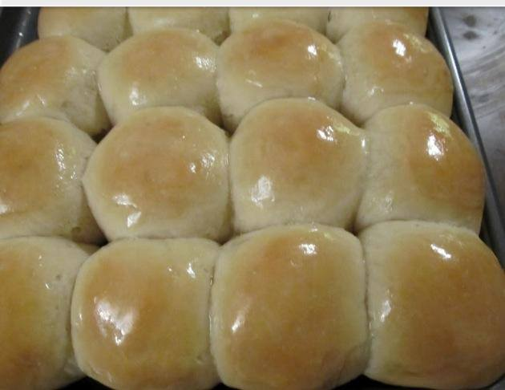
ONE HOUR YEAST ROLLS
1 cup of warm water
1/4 cup sugar
1/3 cup oil
2 tablespoons yeast
1 teaspoon salt
1 egg, beaten
3 1/3 cup flour
1.) In a large bowl, mix together warm water, sugar, oil and yeast. Let stand for 15 minutes until yeast mixture is bubbly.
2.) Stir in salt and beaten egg to yeast mixture.
3.) Gradually add flour. Dough will be kind of sticky, but add enough flour until it's manageable. Let dough rest in the bowl for 10 minutes. I cover mine with a towel. This allows the dough to rise more.
4.) Spray hands with non-stick cooking spray (such as Pam) and form dough into balls. Place balls so they don't touch on cookie sheet. Let rise for 20 more minutes.
5.) Bake in 375 degree oven for 10 minutes.
6.) Mix 2-3 tablespoons of melted butter with honey (to taste) and brush the top of hot rolls with the honey butter.
7.) Enjoy!

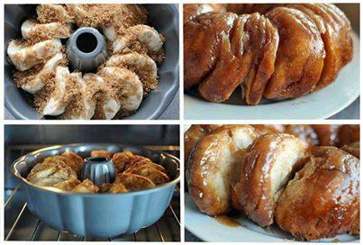
Biscuit CINNAMON Roll!!
WOW these look Awesome and Delicious!!!
Sticky Bun Breakfast Ring:
2 small tubes refrigerator buttermilk biscuits OR 1 tube Pillsbury Grands buttermilk biscuits
3 Tbsp. butter, melted
1/2 C. pancake syrup (any brand you like, I used Mrs. Buttersworth)
1/3 C. packed light brown sugar
1/2 tsp. cinnamon
1/4 C. chopped pecans, optional
1/4 C. chopped almonds, optional
Instructions:
Spray a fluted pan with non-stick spray. Combine the melted butter and syrup in a small bowl and set aside. In another bowl, combine the brown sugar, cinnamon, and nuts (if desired). Place about half of the syrup mixture in the bottom of the pan. Then sprinkle half of the brown sugar mixture on top. Lay the biscuits on the bottom of the pan, overlapping edges (closely together) to form a ring. Top with remaining syrup and sugar mixtures. Bake at 375 degrees for approximately 20-25 minutes or until golden brown. Cool for 1 minute in the pan, then invert onto a serving platter and enjoy!
** You can use 1 1/2 tubes of the Pillsbury Grands buttermilk biscuits if 1 doesn't' seem like enough) and bake it for about 30 minutes.

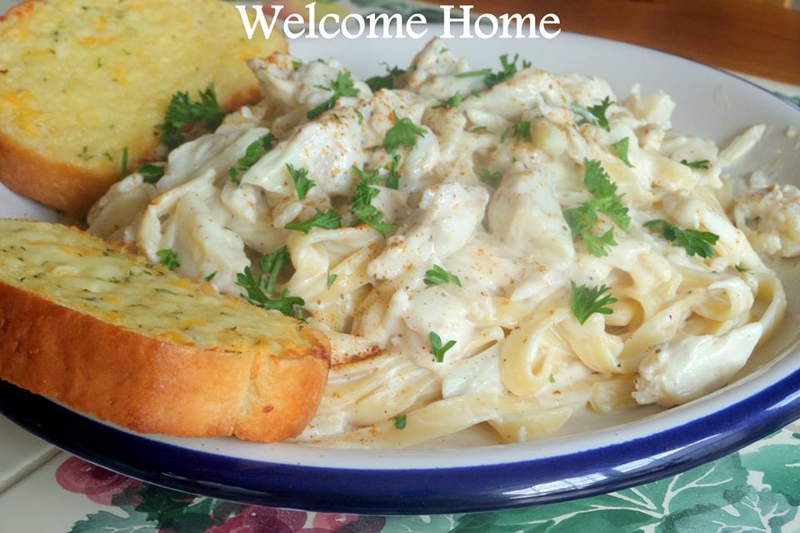
Fettuccine Alfredo with Jumbo Lump Crab
1 pound of fresh Jumbo Lump crab (I get mine at Costco)
2 cloves of garlic minced
pepper to taste
1 stick (1/2 cup) butter
2 Tablespoons all purpose flour
1 pint heavy cream
1 1/2 cups Parmigiana Reggiano cheese
1/4 teaspoon garlic salt
1 teaspoon Old Bay seasoning (or more for a kick)
1/4 teaspoon black pepper
1 tablespoon Parsley
Cook the fettuccine according the package directions. Drain well and set aside.
In a medium saucepan, add the butter and melt over medium heat. Add in garlic and lightly brown. Whisk in flour,and cook for 2-3 minutes, stirring constantly. Slowly whisk in the heavy cream. Allow to come to a slow simmer. Reduce heat to low and add the Parmigiana Reggiano. Stir continually, until the cheese has all melted and the sauce has thickened. Add the garlic salt and pepper and Old Bay seasoning to taste; stir to combine. Pour sauce over well drained fettuccine and toss until covered. Add the crab meat and toss very lightly, being careful not to break up the lumps. Sprinkle with parsley and more Old Bay if desired. Serve with a salad and garlic bread! YUM.

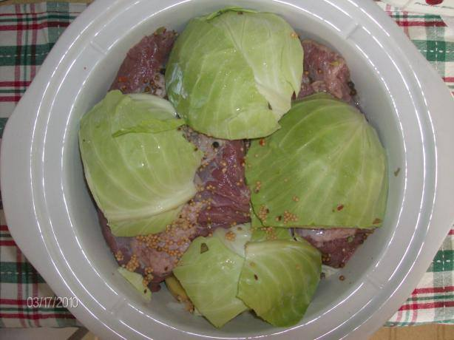
Crock Pot Corned Beef and Cabbage
Ingredients:
4 1/2 lbs corned beef brisket
2 medium onions, quartered
1 head cabbage, cut in small wedges
1/2 teaspoon pepper
3 tablespoons vinegar
3 tablespoons sugar
2 cups water
Directions:
Combine ingredients in crock pot with cabbage on top.
Cut meat to fit, if necessary.
Cover and cook on low 10-12 hours; high 6-7 hours or auto 6-8 hours.

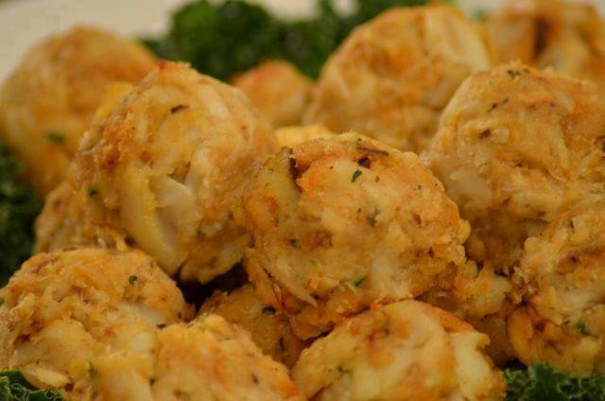
Cajun Crab Balls
“Share” This photo to save the recipe to your page
1 pound crab meat
1 egg, slightly beaten
4 slices bread, broken into small pieces, crusts removed
1/3 cup mayonnaise
2 teaspoons Cajun seasoning
1 teaspoon prepared mustard
dash black pepper
1 Tablespoon Worcestershire sauce
1 teaspoon dried parsley
paprika
butter
•Combine all ingredients except paprika and butter, roll into 1/2 inch balls, place on greased baking sheet, sprinkle with paprika.
•Bake in preheated 375 degree oven for 15 minutes.
•Then turn them over, push an indentation in middle of balls with finger, put dab of butter in indentation, return to oven and bake for 5 more minutes...

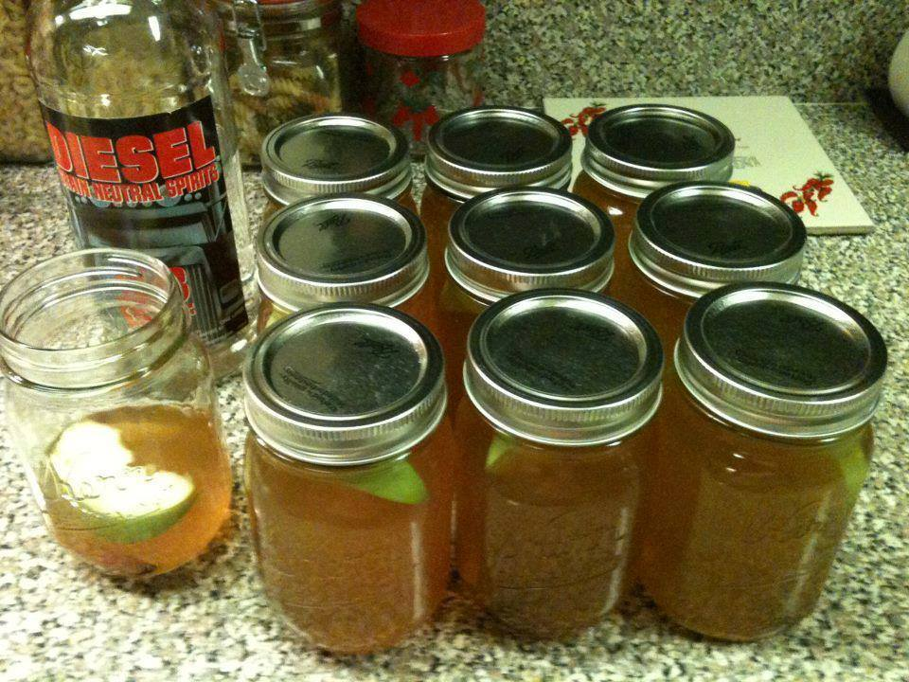
Apple Pie Moonshine (A Southern Apple-Tini)
Ingredients:
1 gallon Apple Cider
1 gallon Apple Juice
1-½ cup Granulated Sugar
1-½ cup Light Brown Sugar
1 tsp apple pie spice (the kind used for apple pie)
8 whole Cinnamon Sticks
2 Granny Smith Apples, cored & sliced this with skin peel on
1 bottle (750ml Size) 150 - 190-Proof Grain Alcohol
Cheesecloth
Directions:
1) Combine all ingredients in a large stock pot, except for the alcohol, and bring to a boil. Mixture will foam up quickly once it reaches boiling.
2) Remove the mixture from heat, stir down, and let cool to room temperature. Once the mixture is completely cool, strain through the cheesecloth. Rinse the pot and return the mixture to the pot. Add in the alcohol. Stir gently to blend.
3) Transfer to sterile mason jars (we used (20) 1/2 pint Mason or Kerr jars). We also divide up the cinnamon sticks so that each jar has 1 or 2 pieces 1-2" long. Fill the jars just to the neck to allow room for the apple slice. A funnel is useful to avoid spilling one drop of this golden deliciousness!
4) Add a slice of Granny Smith apple to each jar. Apples will float to the top. Place the seal and rings and tighten down. These will not seal closed. Do not reheat or attempt to seal!
5) The apple pie is ready for consumption! (though it gets better if you let it mellow for a couple of weeks.) It can be served heated sightly or chilled. Do not overheat or boil! It will evaporate the alcohol. Heat the way you would for hot apple cider or cocoa ONLY so it's not so hot it burns your mouth!
Remember to drink this with caution! For the amount of alcohol in this, you really can’t taste how strong it is; it’s so smooth! Store the jars in a dark, cool room or closet.

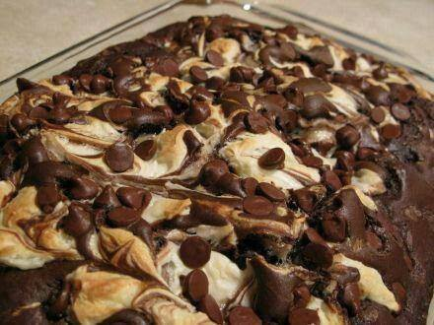
Earthquake Cake
My first experience of an earth Quake cake was while visiting friends in Tennessee. At first, I truly thought she had messed it up somehow, all though the only time I had a cake come out any where looking like that, It was a total disaster.
This earthquake Cake has been around for awhile, and is just as delicious today, as the first time I tasted it!
Ingredients:
1 box Duncan Hines German Chocolate Cake Mix
•3 eggs
•1 1/3 c. water
•1/2 c. oil
•1 c. coconut
•1/2 c. chopped walnuts
•8 oz. softened cream cheese
•1 stick softened butter
•2 c. powdered sugar
•1 tsp. vanilla
•1 pkg. chocolate chips
Directions:
Preheat oven to 350 degrees F and lightly spray a 9’x13’ pan with cooking spray. In the bottom of pan, put the coconut and nuts.
Mix cake mix according to package directions. Spread batter over the nuts and coconut.
In a bowl, mix the cream cheese, butter, vanilla, and powdered sugar until fluffy. Spread over the batter. Sprinkle with chocolate chips. Bake at 350 degrees F for 50 minutes. Cool.
*Duncan Hines suggest this be served with Cool Whip. I personally do not think cool whip would "Add" anything to the cake, but that's a personal choice .. So add a dollop on top of your piece if you want
When this comes out of the oven, it looks like it has exploded (it does not actually explode, so it won't mess up your oven!). That’s why it's called an Earthquake Cake. The cream-cheese mixture sinks and the nuts and coconut rise, and it looks really funky!! But it tastes delicious!!

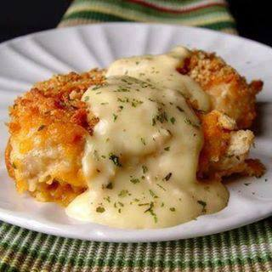
Crispy Cheddar Chicken
2 lbs chicken tenders or 4 large chicken breasts
2 sleeves Ritz crackers
1/4 teaspoons salt
1/8 teaspoon pepper
1/2 cup whole milk
3 cups cheddar cheese, grated
1 teaspoon dried parsley
Sauce:
1 10 ounce can cream of chicken soup
2 tablespoon sour cream
2 tablespoon butter
Crush crackers. If using chicken breasts and not tenders, cut each chicken breast into 3 large pieces. Pour the milk, cheese and cracker crumbs into 3 separate small pans. Toss the salt and pepper into the cracker crumbs and stir the mixture around to combine. Dip each piece of chicken into the milk and then the cheese. Press the cheese into the chicken with your fingers. Then press the cheesy coated chicken into the cracker crumbs and press it in.
Spray a 9×13 pan with cooking spray and lay the chicken inside the pan. Sprinkle the dried parsley over the chicken. Cover the pan with tin foil and bake at 400 degrees for 35 minutes. Remove the tin foil, bake for an additional 10-15 minutes, or until the edges of the chicken are golden brown and crispy.
In a medium sized sauce pan combine the cream of chicken soup, sour cream and butter with a whisk. Stir it over medium high heat until the sauce is nice and hot. Serve over the chicken.

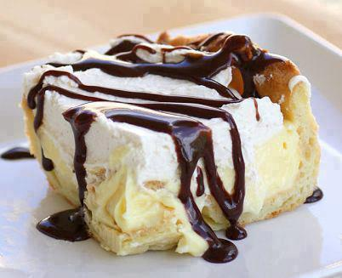
Chocolate Eclair Cake!!!
Ingredients:
1 cup water
1/2 cup butter
1 cup flour
4 large eggs
1 (8 ounce) package cream cheese, softened
1 large box (5.1 ounces) vanilla instant pudding
3 cups milk
1 8 oz. container cool whip (you won’t use the whole container) or one batch of homemade whipped cream
chocolate syrup or homemade chocolate sauce
Instructions:
Preheat oven to 400. Lightly grease a 9″X13″ glass baking pan.
Eclair Crust: In a medium saucepan, melt butter in water and bring to a boil. Remove from heat. Stir in flour. Mix in one egg at a time, mixing completely before adding another egg. Spread mixture into pan, covering the bottom and sides evenly. *If the sides of your pan are too greased you won’t be able to get the mixture to stay up the sides so make sure to just lightly grease.
Bake for 30-40 minutes or until golden brown (Mine only took 25 minutes.) You may want to check it occasionally-you don’t want to overcook the crust, it will ruin the cake! Remove from oven and let cool (don’t touch or push bubbles down).
Filling: Whip cream cheese in a medium bowl. In separate bowl make vanilla pudding. Make sure pudding is thick before mixing in with cream cheese. Slowly add pudding to cream cheese, mixing until there are no lumps. Let cool in fridge. When the crust is completely cooled, pour filling in. Top with layer of cool whip however thick you want it and serve with chocolate syrup. *If you want to make this even better use homemade whipped cream.

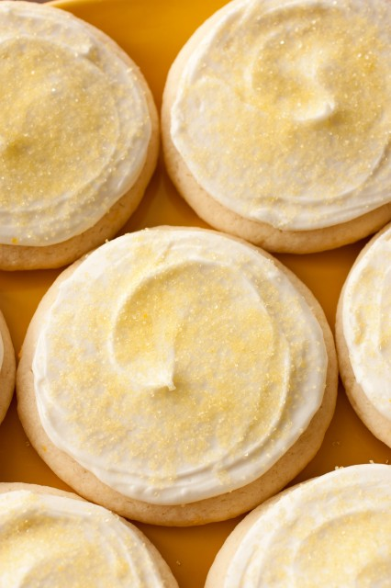
Lemon Sugar Cookies

Ingredients
2 1/2 cups cake flour
2 tsp cornstarch
1 1/2 tsp baking powder
1/2 tsp salt
1/2 cup butter, at room temperature
1/4 cup all vegetable shortening (unflavored), at room temperature
1 cup granulated sugar
Zest of 1 large lemon (1 Tbsp)
1 large egg
1 large egg white
1 tsp lemon extract
1 tsp vanilla extract
Lemon Frosting
1/3 cup salted butter, at room temperature
2 1/2 cups powdered sugar
1/2 tsp lemon extract
2 1/2 - 3 Tbsp fresh lemon juice
yellow food coloring or yellow sprinkles, optional

Directions:
In a bowl combine flour, cornstarch, baking powder and salt and whisk for 30 seconds, set aside. In the bowl of an electric stand mixer, whip together butter, shortening, sugar and lemon zest on medium speed until very pale and fluffy, about 4 minutes, occasionally scrapping down the sides of the bowl. Add in egg and mix until combine, then add egg white, lemon extract and vanilla extract and mix until combine. With mixer running, slowly add in dry ingredients and mix just until combine. Transfer dough to an airtight container and refrigerate 2 hours. Preheat oven to 375 during the last 10 minutes of refrigeration.
Scoop dough out an even 1/4 cup at a time and roll into a ball. Place dough ball on a lightly floured surface, sprinkle top lightly with flour, then using something flat and smooth (such as the storage container lid), press and evenly flatten dough to 1/2" thick (so you should have about a 2 2/3" - 2 3/4 " circular cookie). Transfer flattened dough to a Silpat lined cookie sheet (fitting 6 cookies per cookie sheet) and repeat process with remaining dough. Bake in preheated oven 9 - 11 minutes. Allow to cool 5 minutes on baking sheet before transferring to a wire rack to cool. Cool completely then frost with Lemon Frosting.
For the lemon frosting:
Combine all ingredients in a large mixing bowl, using an electric hand mixer, whip until frosting is smooth and fluffy. Mix in food coloring if desired or sprinkle cookies with yellow sprinkles.

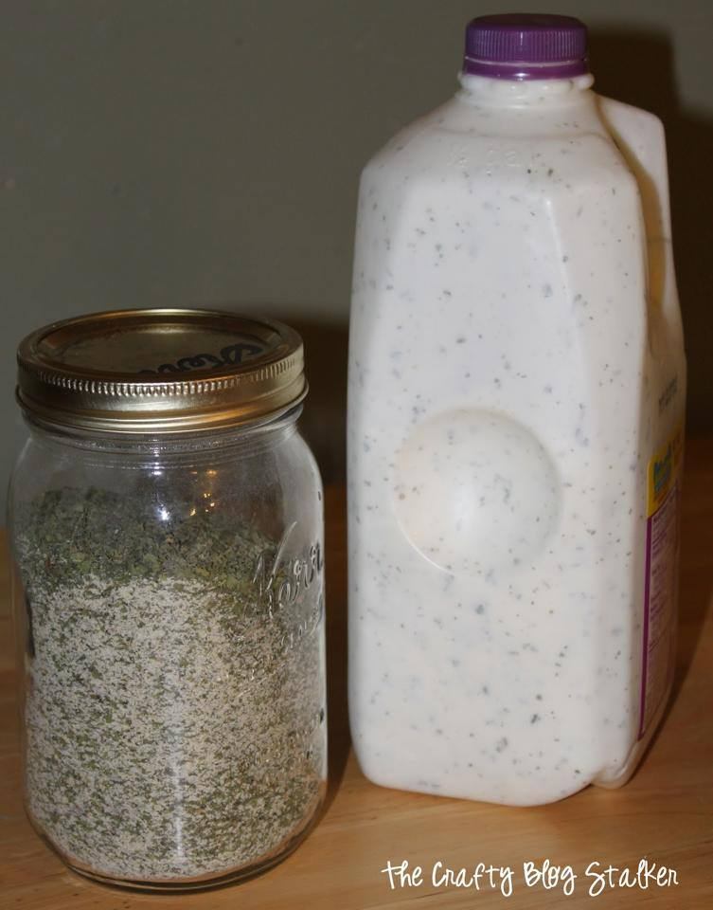
Homemade Ranch Dressing – The Best
Best ranch you'll ever taste and its homemade. Recipe lasts for ever too.
You will need:
Black Pepper ¼ C
Parsley Flakes 1 1/2 C
Garlic Salt ½ C
Kosher Salt 2 Tbsp
Granulated Garlic ¼ C
Granulated Onion 3/4 C
Dill Weed 2 Tbsp
2 cups mayonnaise
2 cups buttermilk
1 1/2 cups sour cream
1 teaspoon of lemon juice
Directions:
1. Combine all ingredients, store in an airtight container. Makes about 3 ½ cups of dry mix
2. To Make Dressing, whisk together 2 Tbsp of mix with 2 Cups each of mayonnaise and buttermilk 1 ½ Cups sour cream, & 1 tsp Lemon Juice. Refrigerate for 2 hours. Makes 1 ¾ Quarts

Homemade Hershey’s Chocolate Syrup
Makes about 16 ounces (2 cups)
Ingredients:
3/4 cup cocoa powder
1 1/4 cups water
1 1/2 cups sugar
1 1/2 teaspoons vanilla extract
Dash salt
Directions:
Use a big saucepan – at least 2 quarts. This will expand when boiling, and overflows will make a big mess on your stovetop! (I use this 3-quart saucepan that was part of a bigger set I received as a gift. It’s my favorite!)
Combine the cocoa powder, water, sugar and salt in a saucepan over medium heat. Mix with a whisk until smooth.
Stir constantly with a whisk or a wooden spoon until it boils.
Allow it to boil for 1-2 minutes.
Remove from heat.
Add vanilla.
Syrup will be very thin/watery. Allow to cool completely and it will thicken to about the same consistency as Hershey’s syrup.
Store the syrup in a mason jar or any other container. It will keep for several weeks in the fridge. If you want to be really sneaky, pour the cooled syrup into an empty or almost-empty Hershey’s syrup container and see if anyone notices the difference!

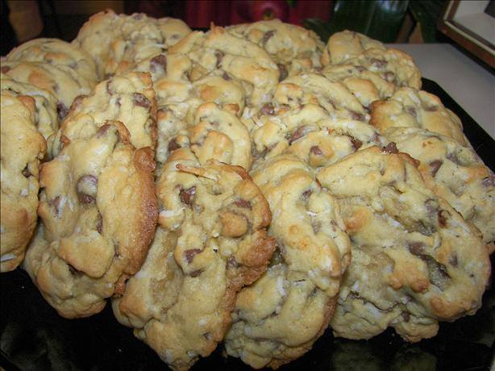
Almond Joy Cookies
how can you go wrong with chocolate and coconut?
Ingredients
1 cup butter
1 1/2 cups white sugar
1 1/2 cups brown sugar
4 eggs
3 teaspoons vanilla
4 1/2 cups flour
2 teaspoons baking soda
1 teaspoon salt
5 cups chocolate chips
2 cups sweetened coconut
2 cups chopped almonds
Directions
Pre-heat oven to 375°F Lightly grease cookie sheets.
Combine dry ingredients, set aside.
In a large bowl, cream the butter and sugars together. Beat in the eggs, one at a time, stir in the vanilla. Stir in the dry ingredients until well mixed then stir in the chocolate chips, coconut and almonds. Drop by rounded tablespoonfuls onto the prepared cookie sheets.
Bake for 8 to 10 minutes. Cool on baking sheet for 5 minutes before removing to a wire rack to cool completely.

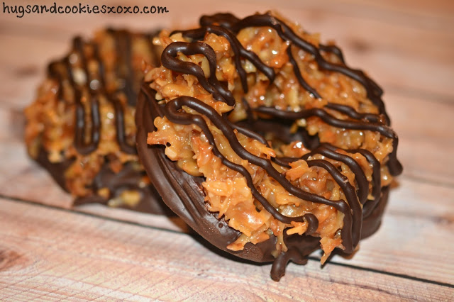
Homemade Somoa Cookies

STEP 1: Slice 16.5 ounces of Pillsbury Sugar Cookie Dough into rounds (The thicker they are, the larger your cookies will be!) I used a straw to make center holes but you can skip this and cut the holes when they come out of the oven which worked better!

Bake on parchment paper lined cookie sheets at 350 for 15-17 minutes or lightly golden. Let cool completely. I made 12 large cookies

STEP 2: DIP THE COOLED COOKIES"
MELT 3 CUPS CHOCOLATE CHIPS (DARK, SEMI OR MILK) AND DIP EACH COOKIE INTO THE CHOCOLATE. SET ON WAX PAPER. YOU CAN DIP JUST BOTTOMS IF U PREFER BUT I DIPPED THE ENTIRE COOKIE.

STEP 3: MAKE THE TOPPING AND PLACE ON COOKIES WHILE CHOCOLATE IS STILL WET.
3 cups shredded sweetened coconut
12 oz. caramels
3 tablespoons cream

Preheat oven to 300 degrees and spread coconut on a baking sheet. Bake it and toss often until lightly toasted and golden -about 15-20 minutes. Cool on baking sheet, stirring occasionally. Set aside.

Place caramels and cream in microwave safe cup and heat until melted and smooth. When smooth, stir in the toasted coconut.

Using a small spoon, carefully spread the topping on cookies. Use any extra chocolate to drizzle across the top! Then u can set in fridge to speed the process of everything firming up. Enjoy!

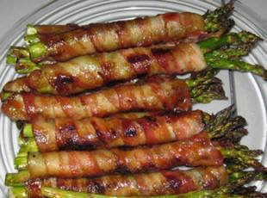
Bacon Wrapped Asparagus
Preheat oven to 400 Divide asparagus into bundes of 3-4 spears Wrap each in a slice of bacon In a saucepan, melt a stick of butter, 1/2 c. brown sugar, 1Tbspn soy sauce, 1/2tsp garlic salt, and 1/4 tsp black pepper and bring to a boil. Pour mix over bundles and bake until bacon looks done.
I would slap these bad boys on the grill!!!

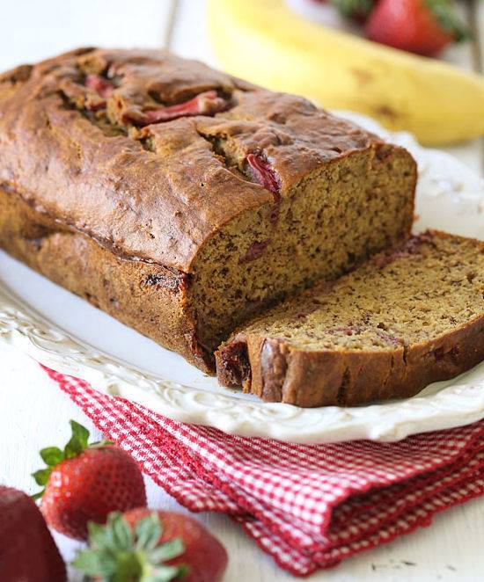
Roasted Strawberry Banana Bread
Servings: 16 • Size: 1 slice • Old Points: 2 pts • Weight Watcher Points+: 2 pt
Calories: 88 • Fat: 2 g • Carb: 19 g • Fiber: 2 g • Protein: 2 g • Sugar: 10 g
Sodium: 111 mg • Cholest: 4 mg
Ingredients:
1-1/4 cups strawberries, diced
3 ripe medium bananas, mashed
2 tbsp unsweetened apple sauce
1 1/4 cups white whole wheat flour
3/4 tsp baking soda
1/4 tsp salt
2 tbsp butter, softened
1/2 cup light brown sugar (not packed)
2 large egg whites
1 tsp vanilla extract
baking spray
Directions:
Preheat oven to 350°F. Lightly spray a loaf pan with baking spray. Place the strawberries on a baking sheet and roast for 25 minutes, remove and set aside.
In a medium bowl, combine flour, baking soda and salt with a wire whisk. Set aside.
In a large bowl cream butter and sugar with an electric mixer. Add egg whites, bananas, apple sauce and vanilla, and beat at medium speed until thick. Scrape down sides of the bowl.
Add flour mixture and blend at low speed until combined, do not over mix. Fold in strawberries and pour batter into the prepared loaf pans; bake in the center rack for about 50 minutes, or until a toothpick inserted in the center comes out clean.
Let the pan cool at least 20 minutes, bread should be room temperature before slicing.

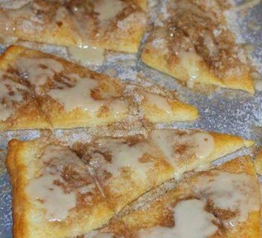
Cinnamon-Sugar Pizza made with Crescent Rolls
*Sugar Crumb Crispies*
1/4 cup butter *make sure butter is cold*
1/4 cup sugar
1/4 cup brown sugar
1/4 tsp cinnamon
dash of salt
1/2 cup flour
1 can Pillsbury Cresent Rolls
Preheat oven to 400 degrees F
Cut in butter to sugars, cinnamon, and salt and flour to form crumbs.
On an ungreased cookie sheet, separate crescent roll dough into 8 triangles. Sprinkle crumbs on top.
Bake at 400 degrees for 8-12 minutes.
After they were cooked and cooled I cut them into smaller triangles but you can leave them big too!
GLAZE
1/2 cup powdered sugar *I like my glaze thicker, so if the glaze is too runny, just add more powdered sugar to get yours to the desired consistency.*
1 Tbsp. softened butter
1-1/4 tsp. vanilla
1 to 1-1/2 Tbsp. milk
Blend together and drizzle over Sugar Crumb Crispies
Enjoy!

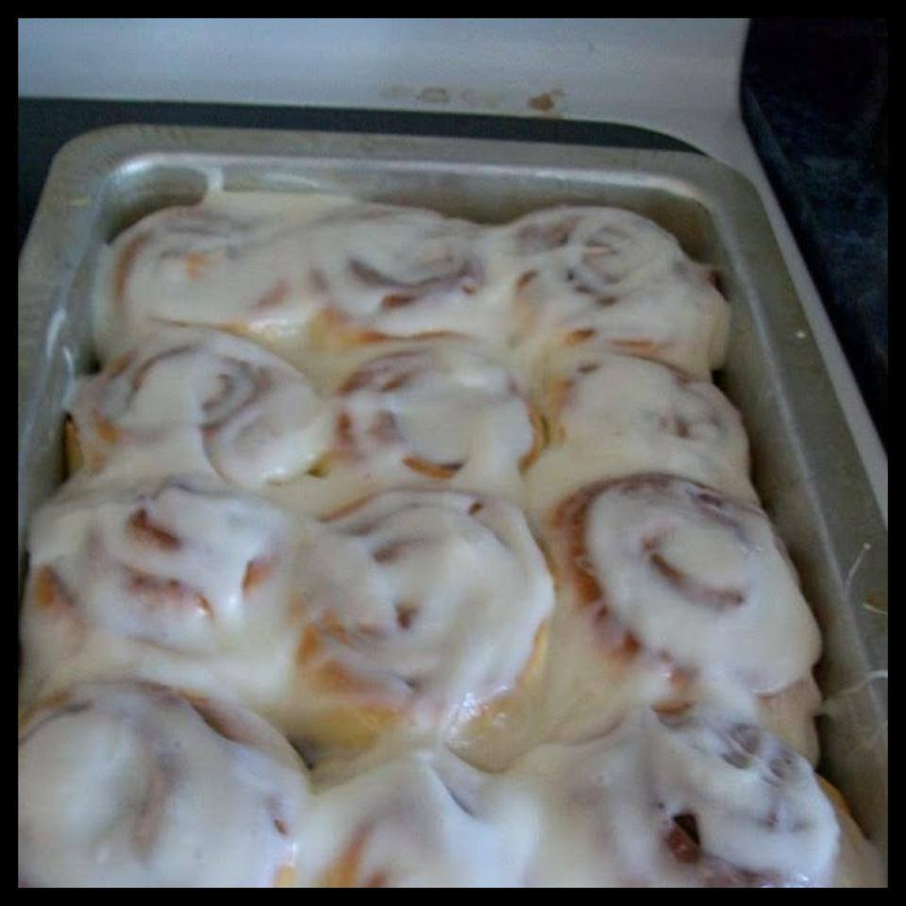
ONE HOUR CINNAMON ROLLS
This recipe will yield 24 regular size rolls or around 12 HUGE rolls. I like mine huge, lol! Cut recipe in half for less.
~3 1/2 cups of warm water
~3/4 sugar
~1/2 cup of oil (vegetable is fine)
~6 tablespoons of quick rise yeast
~1 tablespoon of salt
~3 eggs
~10 1/2 cups of all-purpose flour (yes, that's right, lol)
CINNAMON SUGAR
~1 cup of sugar
~1 Tablespoon of cinnamon
FROSTING
~1/2 cup of butter
~2 dashes of salt
~2 teaspoons of vanilla extract
~6 cups of powdered sugar
~milk (as needed)
**An additional 1/2 cup of butter is needed (separated in half for each half of dough) for spreading on dough with cinnamon sugar.
**Make a double batch of frosting if you like a lot of it.
1.) Mix first 4 ingredients together (water, sugar, oil, yeast) and let sit for 15 minutes.
2.) Then add the salt, eggs and flour. Mix together for 10 minutes, then let sit for 10 minutes.
3.) Oil counter or cutting board and dump out dough. Divide dough in half.
4.) Roll out one half into rectangle. Spread with 1/4 cup melted butter and then half of cinnamon sugar mixture.
5.) Roll up tight, but not too tight.
6.) Divide into 12 rolls and place on greased cookie sheet. Let rise on cookie sheet for 10 minutes. Cut dough in half, cut halves in half, etc.
7.) Repeat with other half of dough.
8.) Bake for 12-15 minutes at 400 degrees.
Enjoy!

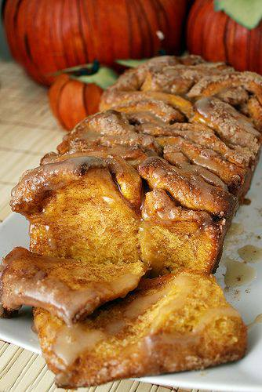
Pull-Apart Cinnamon Sugar Pumpkin Bread with Buttered Rum Glaze

Ingredients
Bread
2 Tbsp unsalted butter
1/2 cup milk
2 1/4 teaspoons (1 envelope) active dry yeast
3/4 cup pumpkin puree
1/4 cup white sugar
1 tsp salt
2 1/2 cups bread flour
1 cup granulated sugar
2 tsp ground cinnamon
1/2 tsp fresh ground nutmeg
2 Tbsp unsalted butter
Buttered Rum Glaze
2 Tbsp unsalted butter
1/8 cup brown sugar
1 1/2 Tbsp milk
3/4 cup powdered sugar
1 Tbsp rum *

*The recipe I used called for just a 1/4 tsp of rum but I really wanted to be able to taste the rum, so I upped it to a full tablespoon. It was just right for my taste, adding a nice warmth to the glaze. If you’re not into rum you can sub a teaspoon of vanilla extract.

Directions
In a saucepan over medium-high heat, brown 2 tablespoons of butter, letting it bubble up and turn a dark golden brown but being careful not to allow it burn (turn black). Once browned, remove the pan from the heat and carefully add the milk, return to stove and heat through.**** Pour the milk and butter into the bowl of standing mixer (fitted with a dough hook) and allow to cool so it is no longer hot but also not cool (about 100-110 degrees F). Once it has reached a warm but not hot temperature add the yeast and 1/4 cup of sugar and allow to proof (this can take up to 8 minutes, the top will look foamy and the liquid cloudy). Then add the the pumpkin, salt, and 1 cup of flour. Stir until combined then add the rest of the flour 1/2 cup at a time and knead for 6 minutes, until the dough is smooth and elastic and just slightly sticky. If the dough is too moist, add extra flour 1 tablespoon at a time. Move dough to a lightly oiled bowl and cover with a clean towel. Allow to rise in a warm place for 60-90 minutes or until doubled in size. While dough is rising, brown another 2 tablespoons of butter. Add the sugar, cinnamon, and nutmeg and mix well.** Making sure sugar evenly absorbs the butter. Set aside. Next, grease and flour a 9×5 loaf pan and set aside. When the dough has doubled in size, punch it down and flip out onto a clean floured surface and knead with hands for 1-2 minutes. Roll dough into a 20×12 inch rectangle.*** Evenly sprinkle the dough with the cinnamon sugar mixture and press into dough with palms of the hand. Cut the rectangle into 6 strips. Lay strips on top of each other and cut each strip into 6 even squares (cut in half then each half into thirds). Stack strips vertically into the loaf pan. Cover the pan with a clean towel and let rise for 30-45 minutes. In the meantime preheat an oven to 350 degrees. After rising in the pan bake for 30-40 minutes (mine took 37 exactly) or until top is a very deep golden brown. To prepare the glaze, heat the butter, milk, and brown sugar in a small saucepan. Bring to boil then immediately remove the pan from the heat and stir in the rum and powdered sugar. **Of course I didn’t properly read this section of the directions… I was supposed to melt the butter and brush the dough with the butter then adding the sugar on top of the butter (instead of mixing it all together and sprinkling) but it worked my way so that’s how I am listing it. It’s really your call! *** If dough is difficult to roll out, cover with a towel and allow to relax for a few minutes then try again. **** My milk was room temperature. Adding it cold to the butter can result in clumping. Willow Bird Baking called for removing the butter from the pan, then heating the milk, then adding the butter back to the milk. I was lazy which is why I skipped that step. You can also heat the milk separately in the microwave if you’d like.
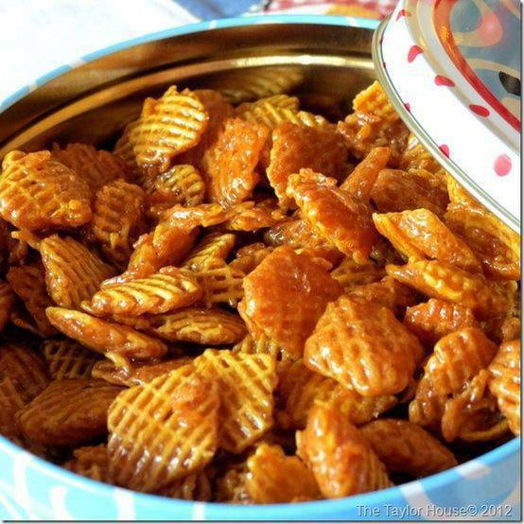
Caramel Crispix
Ingredients
2 small boxes of Crispix Cereal
2 cups of butter
2 cups of brown sugar
½ cup Light Karo syrup
½ tsp Vanilla
½ tsp Baking Soda
Instructions
Melt butter in a sauce pan. Add brown sugar and bring to a boil. Add Karo syrup, vanilla and baking soda. Put the cereal in a large bowl then pour mixture over the cereal.

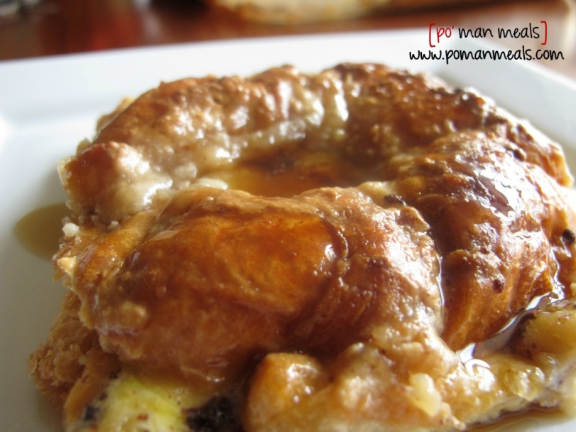
Baked Croissant French Toast

This is another dish that is perfect for Christmas morning! Just make it the day before, for instance christmas eve, and pop in the oven as everyone is opening gifts. it is very decadent and perfect for special occasions.

prep time: 15 minutes: cook time: 45 minutes: yield: 8 servings

Ingredients:

6 croissants - cut lengthwise
4 ounces softened cream cheese - softened
1/2 stick butter - softened
1/2 cup syrup -
6 eggs -
1 1/2 cup half and half -
1 teaspoon vanilla -
1/2 teaspoon cinnamon -

Instructions:
Preheat oven to 350 degrees.
generously butter a 9x13 inch baking dish. Cut croissants in half lengthwise and place in bottom of the dish. if you prefer, you can tear them into pieces. In a small bowl, beat the cream cheese, butter and maple syrup with a hand mixer. dollop the mixture over the croissants. Combine the eggs, half and half, vanilla and cinnamon well in another bowl. Mix well and pour over top of the croissants.
cover and refrigerate for 8 hours or overnight. Bake uncovered for 30 - 45 minutes, until a knife inserted comes out clean.
serve with powdered sugar, syrup and/or fresh berries. like nuts? toss them in!

THE BEST potato soup recipe ever!
Ingredients:
2 1/2 pounds baby red potatoes, sliced into small bite sized pieces
1/2 regular package uncooked bacon, finely diced
1 medium onion, diced
1/4 bunch celery, diced
8 cups milk
4 cups water
4 chicken bullion cubes (use a cup of the hot potato water to dissolve, then use the cup of hot water in place of one of the above cups of water)
1 teaspoon salt
1 teaspoon black pepper
3/4 cup salted butter
3/4 cup flour
1/4 bunch freshly chopped parsley
1 cup whipping cream
***For garnish:***
Shredded cheese
fried bacon bits
chopped green onions
Directions:
In large pot, boil potatoes in water 10 minutes. Drain and set aside. In sauté pan, cook bacon until crisp. Drain bacon fat and place on paper towel over plate to drain more. Add onion and celery to bacon pan over medium-high heat until celery is tender, about 5 minutes. To the large potato pan, add milk, water, bullion, salt and pepper. Cook over medium-high heat until mixture is very hot, about 8 minutes, stirring often. Do not let mixture boil. In small, heavy saucepan melt butter. Add flour and mix well. Cook over medium-low heat until mixture bubbles, stirring 2 to 3 minutes to make a roux. While constantly stirring soup, add roux slowly until soup is thick and creamy, about 4 minutes. Stir in parsley, reserved potatoes, and cream. Garnish with cheese, bacon bits, onions or all three. Serve hot!

No Bake Pumpkin Oatmeal Cookies
Ingredients:
1.5 cups white sugar
0.5 cups brown sugar
0.75 cups butter
0.66 cups milk
1 (3.4 oz) box instant pumpkin spice pudding mix (if you can’t find sub vanilla pudding & 1 TBSP pumpkin pie spice)
3.5 cups quick cooking oats
1 tsp pumpkin pie spice
1 tsp vanilla extract
Directions:
In a saucepan, combine sugars, butter and milk. Bring to a boil. Boil 2 minutes. Remove from heat and add in the pudding mix, stirring to combine completely. Add in pumpkin pie spice, vanilla and oats. Stir to combine and let stand for 5 minutes. Drop by rounded tablespoonfuls onto waxed paper, and allow to cool completely. Store in airtight container.
Freezing Directions:
Follow directions above. When completely cool, transfer to gallon sized freezer storage bag.
Servings: 36 cookies

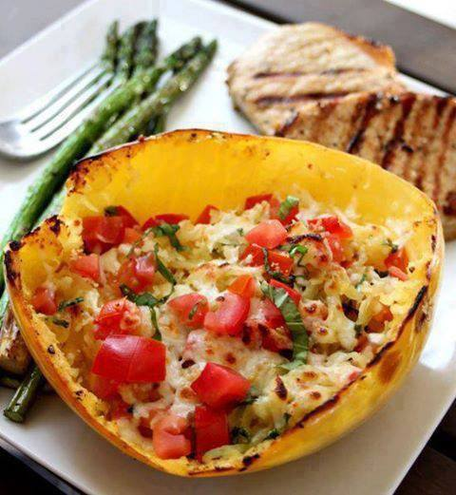
Baked Margarita Spaghetti Squash
Not only is it healthy, but its gluten free as well!
Ingredients:
1 large spaghetti squash
2 tbsp. olive oil
1 large Roma tomato, finely chopped
2 tbsp. finely chopped fresh basil
1/4 cup shredded mozzarella cheese
1 tsp. each salt & pepper
1 tsp. garlic powder
Steps:
Preheat the oven to 400 degrees. Using a large knife or a cleaver, slice the spaghetti squash in half lengthwise down the middle. Use a spoon to remove the seeds and center strings. Drizzle the two halves with olive oil and then sprinkle with salt, pepper and garlic powder. Place the squash, open side down on a cookie sheet and bake for 30 minutes. Remove from the oven, check to see if the squash is soft and easily comes up with a fork into a spaghetti like texture. If it’s too hard to remove, cook for another 10 minutes. Remove from the oven, scrape and fluff the stringy squash with a fork. Leave the squash in the skin. Turn the oven up to broil. Add the tomatoes and fresh basil into the squash, stir and top with the mozzarella cheese. Place in the broiler for 3-4 minutes, until the cheese is melted and slightly browned. Allow to cool for 5 minutes before serving the squash.

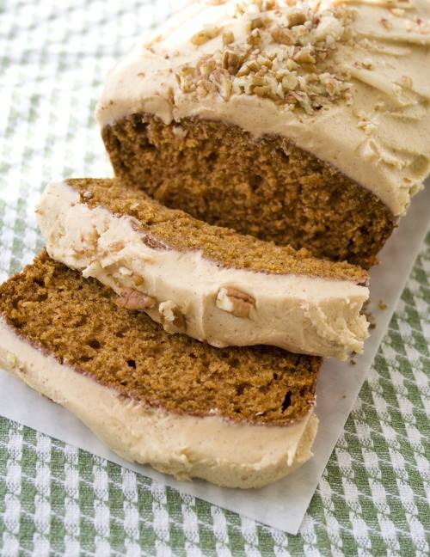
Pumpkin Bread with Pumpkin Butter Cream

Ingredients:
1 3/4 cups all-purpose flour
1 1/2 teaspoons ground cinnamon
1 teaspoon baking powder
1 teaspoon baking soda
1/2 teaspoon salt
1/2 teaspoon ground nutmeg
1/2 teaspoon ground allspice
2 large eggs
3/4 cup packed dark brown sugar (You can substituted light brown sugar)
1/3 cup granulated sugar
2 teaspoons freshly grated orange zest (I omitted this)
1 teaspoon freshly grated lemon zest (I left this out, too)
1/2 cup canola oil
1 1/4 cups canned pure pumpkin puree
1/2 cup chopped, toasted pecans or walnuts, optional
(I didn’t add the nuts to the batter, but sprinkled them on top of the frosted loaf instead)
Position your oven rack in the middle of the oven, and preheat oven to 325 degrees. Grease and flour a 9 x 5″ loaf pan; set aside.
Directions:
Combine flour, cinnamon, baking powder, baking soda, salt, nutmeg, and allspice in a medium bowl and whisk until thoroughly combined; set aside.
In another bowl, or bowl of an electric mixer, beat eggs on medium-high speed for two minutes or until lightened in color. Add the brown sugar, mixing for about 2 minutes, then the granulated sugar, mixing for about 1 minute. Add the orange and lemon zests, if using, and beat for another minute. Scrape down the bowl as needed.
Drizzle in the canola oil with beater on medium-low. Reduce speed to low and add the pumpkin puree. Mix until thoroughly combined. Add the dry ingredients in two additions and blend for 10-15 seconds just until incorporated. Fold in the pecans using a rubber spatula.
Spoon the batter into your prepared loaf pan and bake for 60-65 minutes or until a toothpick inserted in center comes out clean. Cool loaf in pan for 10 to 15 minutes, then remove and cool completely on a wire rack.
If you’re going to frost the loaf, you can make the frosting while the loaf is cooling…
PUMPKIN BUTTER CREAM FROSTING
1/4 cup (1/2 stick) unsalted butter, softened
2 Tablespoons canned pure pumpkin puree
1/2 teaspoon ground cinnamon
1/2 teaspoon vanilla
3 cups powdered sugar
2 teaspoons half & half or milk
1/4 to 1/3 cup chopped pecans or walnuts, optional, for sprinkling on top
Cream the butter, pumpkin puree, cinnamon, and vanilla, blending well. Add powdered sugar a cup at a time, blending well after each addition. Add half & half or milk and blend well. NOTE: This makes a very thick butter cream frosting. If you want a thinner, creamier frosting, add more half & half or milk until you get the desired consistency.
After frosting the cooled pumpkin loaf, sprinkle with chopped pecans or walnuts if desired.

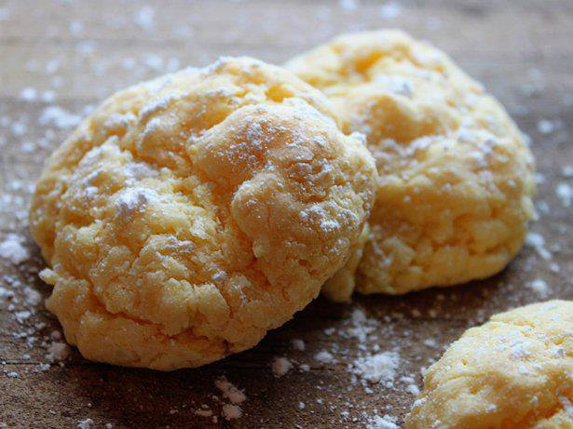
Gooey Butter Cookies
1 package (8 oz) cream cheese, softened
1/2 cup butter, softened
1/4 teaspoon vanilla
1 egg
1 box Betty Crocker® SuperMoist® yellow cake mix
Heat oven to 375 degrees. In medium bowl, beat cream cheese and butter with spoon until well blended. Stir in vanilla and egg. Add cake mix; stir until well combined. Shape dough into 1-inch balls; roll in powdered sugar to coat. Place 1 inch apart on ungreased cookie sheets. Bake 11 to 15 minutes or until set. Remove from cookie sheets to cooling

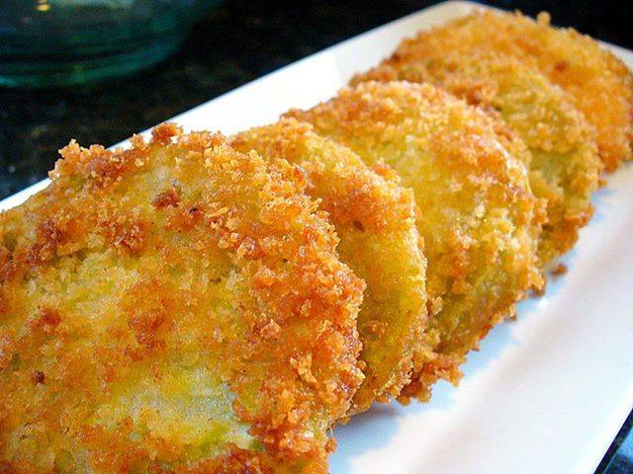
Fried Green Tomatoes
4 green tomatoes, cut into 1/4-inch rings
Kosher salt and freshly ground black pepper
3/4 cup all-purpose flour
1 tablespoon garlic powder
4 eggs
2 tablespoons milk
1 1/2 cups panko bread crumbs
Pinch cayenne pepper
Pinch paprika
Buttermilk Dipping Sauce, recipe follows
In a deep-fryer, preheat oil to 350 degrees F. Season tomatoes, on both sides, with salt and pepper. Place flour and garlic powder in a shallow dish. In another shallow dish, beat eggs with the milk. In another dish, mix bread crumbs with cayenne and paprika. Dredge tomatoes through the flour, then the eggs, and then through the bread crumbs. Add only a few pieces to the fryer at a time, so they can cook evenly, about 2 to 3 minutes. Drain on paper towels and serve with Buttermilk Dipping Sauce:
Buttermilk Dipping Sauce:
1 cup apple cider
1 tablespoon brown sugar
3/4 cup buttermilk
3/4 cup mayonnaise
2 tablespoons Neelys BBQ sauce
1 lime, juiced
4 scallions, sliced thin
Kosher salt and freshly ground black pepper
In a small saucepan over medium heat, combine the apple cider and brown sugar. Allow to reduce until thick and syrupy. Remove from heat and allow to cool. In a medium bowl, add buttermilk, mayonnaise, BBQ sauce and lime juice and whisk well. Add in the scallions and the apple cider mixture. Cover and refrigerate until ready to serve with Fried Green Tomatoes.

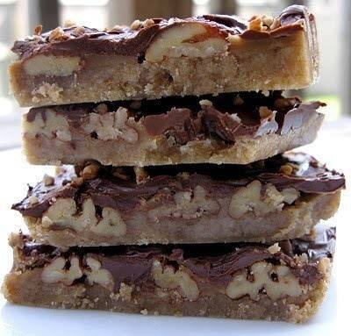
Turtle Cookie Bars
Crust:
2 cups all-purpose flour
1 cup firmly packed brown sugar
1/2 cup butter, softened
2nd Layer
1 cup pecan halves or chopped pecans
2/3 cup butter
1/2 cup firmly packed brown sugar
1 cup milk chocolate morsels
Preheat oven to 350 degrees. Combine first 3 ingredients in a mixing bowl; beat at medium speed with an electric mixer until blended. Pat mixture firmly into an ungreased 13x9 inch pan.
Arrange pecans over crust.
Combine 2/3 cup butter and 1/2 cup brown sugar in a saucepan; bring to a boil over medium high heat, stirring constantly. Cook 3 minutes, stirring constantly. Pour mixture over pecans. Bake at 350 degrees for 15-17 minutes or until golden and bubbly.
Remove from oven; sprinkle with chocolate morsels. Let stand 2-3 minutes or until slightly melted. Gently swirl chocolate with a knife, leaving some morsels whole (do not spread). Let cool on a wire rack at room temperature until chocolate is set. Cut into squares.

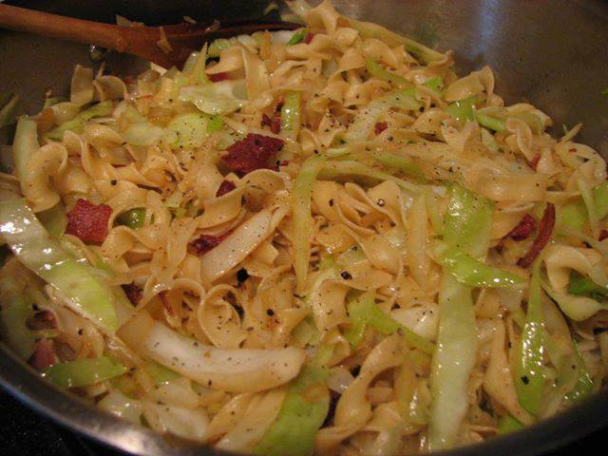
Cabbage & Noodles with Bacon
1 head of cabbage, chopped
1 pound of bacon*
1 large onion, chopped
2-3 large handfuls of egg noodles*
Black pepper
In a large skillet over medium-high heat, cook the bacon until crisp. Remove from the pan and drain on paper towels, then break into bite-sized pieces. (Warning: there’s a chance that you could end up snacking on the bacon bits while you’re finishing dinner. It’s been known to happen here.)
Meanwhile, bring a large pot of salted water to boil for the egg noodles. Add the noodles and cook until done. Drain the noodles and set aside.
Drain some of the bacon fat from the pan, reserving enough to cook the onions. Add the chopped onion to the pan and cook for about 1-2 minutes, or until the onions begin to soften. Add the cabbage to the skillet and cook until tender, stirring occasionally. When the cabbage is tender, add the egg noodles and bacon, mixing thoroughly. Season with pepper. Serve immediately.

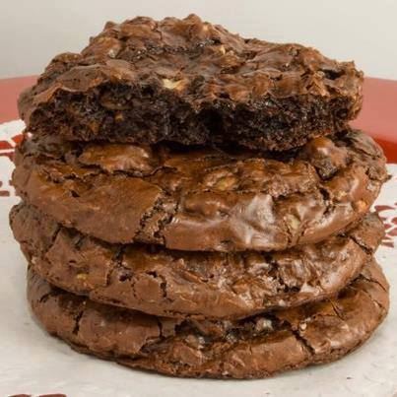
Chocolate Brownie Cookies
1/4 cup all-purpose flour (yes, this is the correct amount!)
1/4 tsp baking powder
1/8 tsp salt
2 large eggs
2/3 cup granulated sugar
1/2 tbsp brewed espresso (or you can use reconstituted espresso powder)
1 tsp vanilla extract
2 tbsp unsalted butter
5 oz extra-bittersweet chocolate (70% or higher), chopped
2 oz unsweetened chocolate, chopped
3/4 cup mini chocolate chips
Preheat oven to 375°F. Line 2 baking sheets with parchment paper.
In a small bowl, whisk together the flour, baking powder, and salt. Set aside. In the bowl of an electric mixer, briefly whip the eggs to break them up. Add the sugar, espresso, and vanilla and beat on high speed for 15 minutes, until thick. (This will help add body to the batter because there is so little flour in the recipe.)
While the eggs are whipping, place the butter in the top of a double boiler, or in a small metal bowl suspended over a pot of simmering (not boiling) water, and scatter the extra-bittersweet and unsweetened chocolate on top. Heat until the butter and chocolate melt. Remove the boiler top from over the water and stir the chocolate and butter until smooth.
Gently fold the chocolate mixture into the egg mixture until partially combined (there should still be some streaks). Add the flour mixture to the batter and carefully fold it in. Fold in the chocolate chips. If the batter is very runny, let it rest until it thickens slightly, about 5 minutes.
Drop the batter by heaping teaspoonfuls onto the prepared baking sheets and bake until puffed and cracked, 8 to 9 minutes. Cool on a wire rack before removing from the baking sheets.
NOTE: Most of us use tablespoons to measure out cookie dough. This calls for teaspoons, 1/3 the size of normal! If you want larger cookies or more of them, double the recipe.

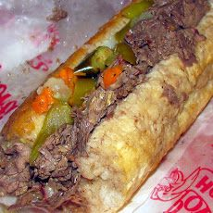
Crock Pot Chicago Italian Beef Sandwiches
1 teaspoon salt
1 teaspoon black pepper, ground
1 teaspoon oregano
1 teaspoon basil
1 teaspoon onion salt
2 -3 cups water or 2 -3 cups broth
1 teaspoon parsley
1 teaspoon garlic powder
1 bay leaf
1 (2/3 ounce) package dried Italian salad dressing mix
5 lbs rump roast or 5 lbs chuck roast
3 beef bouillon cubes (optional)
1 green pepper, sliced (optional)
In a medium saucepan over medium heat. Combine the salt, pepper, oregano, basil, onion salt, water, parsley, garlic powder, water, bay leaf and salad dressing mix. Stir well and bring just to a boil.
Place roast in a slow cooker and pour mixture over the roast. cover and cook on low setting for 10-12 hrs on low or high for 4-5 hours.
The best thing to do is to have it cook in the slow cooker until it is cooked through, remove the bay leaf, then shred it and return it to the juice for about an hour.
Optional - Last 45 minutes add bouillon cubes and green pepper. If you use broth instead of water don't add the bouillon cubes.
Serve on Italian bread.

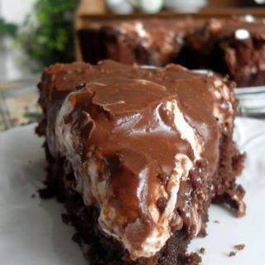
Fudge Brownie Pie
3/4 cup flour
1 cup of regular sugar
1/4 cup unsweetened cocoa powder, sifted
1 teaspoon baking powder
1/4 tsp salt
4 ounces butter, melted OR MARGERINE
2 large eggs, beaten
2 teaspoons vanilla
1/2 cup chopped toasted pecans
2 handfuls of mini marshmallows
For the frosting:
2 ounces butter, melted (1/4 cup)
1 ounce cocoa powder, sifted (1/4 cup)
2 ounces evaporated milk (1/4 cup)
1 cup powdered sugar, sifted (8 ounces)
Preheat the oven to 350 degrees. Butter a 9 inch spring form pan set aside.
Whisk together the flour, sugar, cocoa powder, baking powder and salt in a bowl. Beat together the butter, eggs and vanilla. Add to the dry ingredients and mix until smooth. Stir in the toasted nuts. Pour into the prepared pan.
Bake on a middle shelf of the oven for 25 to 30 minutes, or until a toothpick inserted in the center comes out clean. Immediately sprinkle the marshmallows on top and return to the oven for a few minutes to melt the marshmallows. Remove from the oven and carefully spread the chocolate frosting over top.
To make the chocolate frosting mix all ingredients together in a bowl, beating with an electric whisk until smooth and thick. Spread on the hot marshmallows. Let cool completely. Cut into wedges to serve.

Bacon Bombs
1 can (8ct.) Pillsbury Grands Flaky Layers Biscuits
Cubed Mozzarella Cheese (1-1″ cube per Bomb)
2 lbs. of Bacon (1 slice per Bomb)
Sticks
Oil for frying (I used Canola)
Directions:
Cube up the Cheese, and cut each Biscuit into fourths. Place one piece of Cheese inside a Biscuit quarter, and
roll it up in there, nice and tight… Wrap each rolled Bomb in a slice of Bacon, and secure it with a skewer or
toothpick…
In a med/large pot, heat up approx. 2″ of Oil (to 350 degrees) and fry them up in small batches. Maybe one or
two at a time, the oil will expand so stay close… Drain them on some Paper Towel, but serve them up good and warm. YUM!!

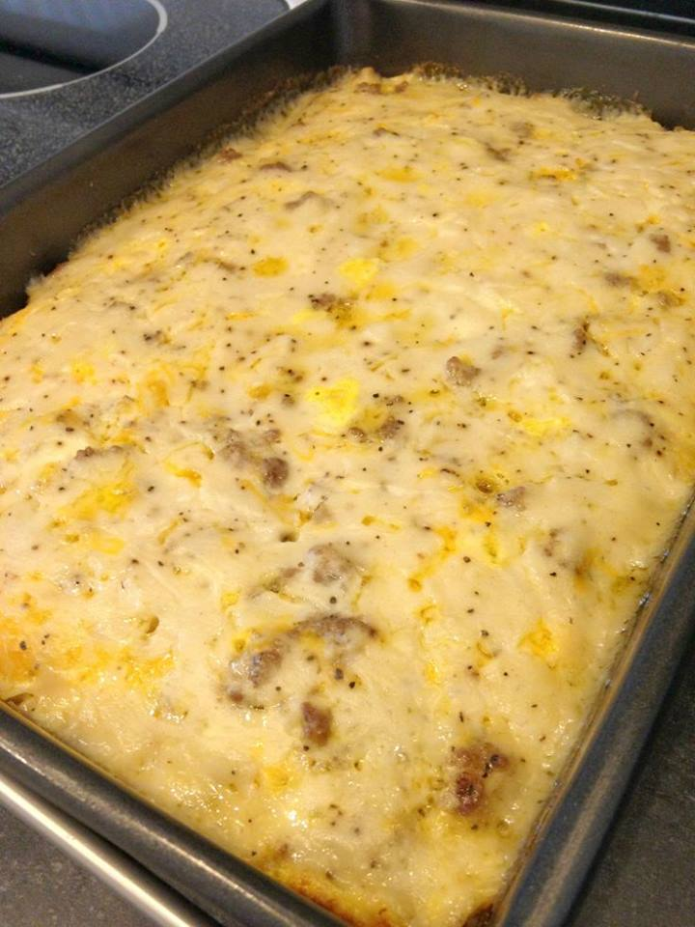
Biscuits & Gravy Casserole
Ingredients
1 pound sausage
1 1/2 ounces pork gravy mix ( 1 package of Pioneer Brand Peppered Sausage Gravy Mix )
1 cup cheddar cheese, shredded
6 eggs
1/2 cup milk
to taste salt
to taste black pepper
1 Can (8 oz) biscuits ( 1 can Pillsbury Grands Biscuits )
Directions
Preheat oven to 350 degree's. Take a 9x13 pan and spray it with Pam or whatever you like to use. Then take the Biscuits and it into 1" pieces and line bottom of pan. Brown Sausage and scatter over biscuits. Sprinkle with Cheddar Cheese. Whisk eggs and milk with a pinch of salt and pepper and pour it over the pan. Make Gravy mix per package directions and pour over. Bake in the oven for about 30-45 minutes.

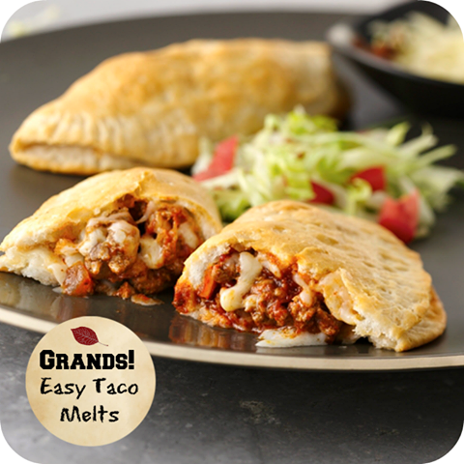
Easy Taco Melts
Here's what you need:
1 package (1 oz) Old El Paso® taco seasoning mix
2/3 cup water
1 1/2 cups Old El Paso® Thick 'n Chunky salsa
1 lb lean (at least 80%) ground beef, cooked, drained
1 can (16.3 oz) Pillsbury® Grands!® biscuits
1 cup shredded Monterey Jack cheese or Mexican cheese blend (4 oz)
1 cup sour cream, if desired
Here's what you need to do:
1) In medium saucepan, cook taco seasoning mix, water, 1/2 cup of the salsa and cooked ground beef until thickened.
2) Press each biscuit into 6-inch round. Spoon 1/3 cup meat mixture and 1 tablespoon cheese onto center of each round. Fold dough in half over filling; press to seal. Place on greased cookie sheet.
3) Bake at 375°F 9 to 14 minutes or until golden brown. Serve with remaining salsa, cheese and sour cream.

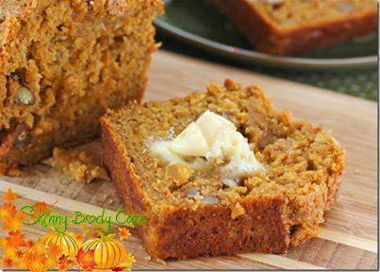
Snickerdoodle Pumpkin Walnut Bread!!
Makes 2 loaves...
Ingredients:
2 cups all-purpose flour
1 1/2 cups white whole wheat flour (or all-purpose flour)
2 cups light brown sugar, packed
1/3 cups granulated sugar
2 teaspoons baking soda
1 teaspoon baking powder
1 teaspoon salt
1 teaspoon freshly grated nutmeg
1 teaspoon cinnamon
1 teaspoon allspice
1/2 teaspoon cloves
1 15-ounce can pumpkin puree, or just under two cups
1 cup vegetable oil
1/3 cup honey
1/3 cup water
1/2 cup of chopped walnuts
FOR THE STREUSEL TOPPING:
1/2 cup flour
1/2 cup granulated sugar
1/2 teaspoon salt
2 tablespoons cinnamon
2 tablespoons butter, I doubled the butter to make it extra-good
Directions:
Preheat oven to 350 degrees F. Place a rack in the center of the oven. Grease and flour two loaf pans and set aside.
In a large bowl, whisk together flours, sugars, baking soda, baking powder, salt and spices.
In a medium bowl, carefully whisk together pumpkin puree, oil, honey and water. add walnuts
Add the wet ingredients to the dry ingredients and use a spatula to fold all of the ingredients together. Make sure to scrape the bottom of the bowl well, incorporating all the dry ingredients.
Divide the dough between the two greased pans and sprinkle with the streusel topping. Bake for 1 hour to 1 hour and 15 minutes, or until a skewer inserted in the center comes out clean. Remove from the oven. Let rest in the pans for 15 minutes, then invert onto a cooling rack. Delicious served warm with a smear of butter!

Almond Joy Cookies
how can you go wrong with chocolate and coconut?
Ingredients
1 cup butter
1 1/2 cups white sugar
1 1/2 cups brown sugar
4 eggs
3 teaspoons vanilla
4 1/2 cups flour
2 teaspoons baking soda
1 teaspoon salt
5 cups chocolate chips
2 cups sweetened coconut
2 cups chopped almonds

Directions
Pre-heat oven to 375°F Lightly grease cookie sheets.
Combine dry ingredients, set aside.
In a large bowl, cream the butter and sugars together. Beat in the eggs, one at a time, stir in the vanilla. Stir in the dry ingredients until well mixed then stir in the chocolate chips, coconut and almonds. Drop by rounded tablespoonfuls onto the prepared cookie sheets.
Bake for 8 to 10 minutes. Cool on baking sheet for 5 minutes before removing to a wire rack to cool completely.

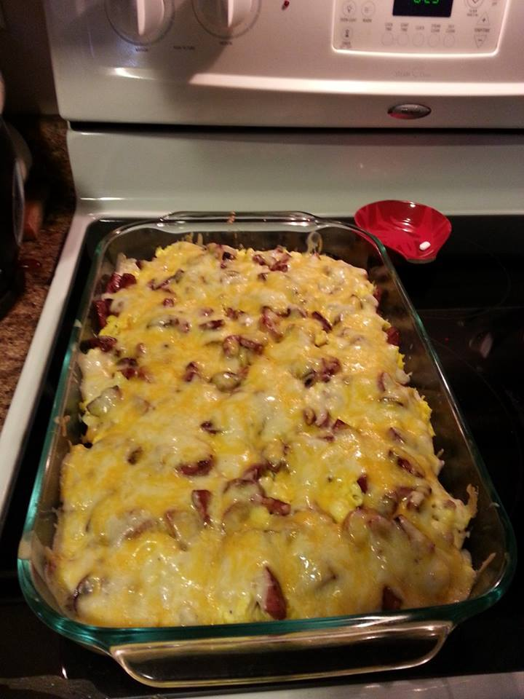
Easy Serve Breakfast

Bite size Biscuits Lining a Baking Dish, Bake until almost done . Then Scramble up some Eggs and cover the top of Biscuits with them. Fry up som Sausage, Ham or Bacon.. and Sprinkle the bits over the top of the eggs. Then make some Sausage or Country Grave, and Spred a Thin layer over all.. then smother the entire thing with Cheese. Bake it until its done, and the cheese is Fully Melted. Oven Temp about 350 degrees.. Baking time 15-20 Minutes.. or until Biscuits are cooked well and cheese is melted.

